TerrainWorks

Elk River-NetMap Watershed Restoration Analysis
Lee Benda and Kevin Andras
Mt Shasta, CA
3-2-2017

Contents
Elk River-NetMap Watershed Restoration Analysis 0
Elk River Watershed Restoration Analysis 2
Abstract 2
1.0 Introduction 2
2.0 Study Area 3
3.0 Methods 4
3.1 NetMap’s Virtual Watersheds and Smart, Synthetic River Networks 4
3.2 Attributes and Landforms in NetMap’s Elk River virtual watershed 7
3.3 Analysis Tools Included in the Elk River-NetMap System 7
3.4 Multiple Scales of Analysis in Support of Restoration Watershed Analysis 8
4.0 Analysis Results 9
4.1 Valley Floor and Floodplain Ecosystems 9
4.2 Fish and Beaver Habitats 16
4.3 Riparian Analysis 22
4.4 Erosion (Slope Stability) Analysis 33
4.5 Forest Road Analysis 36
4.6 Upslope Sources of Large Wood 45
5.0 Setting Restoration Priorities 49
5.1 Linking NetMap Outputs to Current Restoration Planning Objectives and Site Selection 49
5.2 Where are the Best Coho Salmon Habitats? 52
5.3 Where Additional Stream Shade is Needed Most? 54
5.4 Where In-Stream Wood is Needed Most? 55
5.5 Where Valley Floor-Floodplain Ecological Hotspots Could be Enhanced? 56
5.6 At What Locations Would Road Surface Upgrades Reduce Sediment Delivery? 57
5.7 At What Locations Would New Drainage Features Optimize Reductions in Road-Stream Connectivity and Sediment Delivery to Streams? 57
References 58

Elk River Watershed Restoration Analysis

Abstract
A major challenge in river restoration is to characterize the fluvial system and its influences on aquatic habitats through riparian processes, erosion processes and current and historical land use activities. Intensive land use on valley floors often predates the earliest remote sensing: levees, dikes, dams, and other structures alter valley-floor morphology, river channels and flow regimes. Consequently, morphological patterns indicative of the fluvial landscape, including multiple channels, extensive floodplains, wetlands, and fluvial-riparian and tributary-confluence dynamics, can be obscured, and information to develop appropriate and cost effective river restoration strategies can be unavailable. To address this issue in the Elk River in southwest Oregon, we coupled general principles of hydro-geomorphic processes with computer tools (NetMap) to characterize the fluvial landscape. Using 1m LiDAR merged with 10m digital elevation models, we applied the NetMap system of virtual watersheds, smart river networks and computer tools to characterize numerous watershed attributes, including the channel network, anadromous and resident fish habitats, floodplains and valley floor morphology, current shade – thermal energy, current in-stream wood recruitment, slope stability, and forest roads. This information can be used to help prioritize where instream, riparian and road related restoration projects would be most ecologically and cost effective.

1.0 Introduction
A watershed scale perspective that encompasses the complete fluvial landscape is critical for successful river restoration (Logan and Furze, 2002, Bannister et al., 2005, Kondolf et al., 2006, Nilsson et al., 2007). The fluvial landscape includes the physical and biological features created by interacting fluvial, terrestrial, and ecological processes. It includes all the surface landforms and biologic communities that affect and are affected by the flow of water, sediment and organic materials through the network of river corridors including active and former river channels, off-channel water bodies including wetlands, floodplains, terraces, and riparian vegetation (Fausch et al., 2002, Ward et al., 2002, Nakamura, 2006) and subsurface patterns of hyporheic flow and associated organisms (Poole et al., 2006).
River restoration planning, design and implementation (levee removal, channel engineering, placement of in stream structures, planting riparian vegetation, etc.) necessarily and typically occur at the scale of individual channel reaches (100 – 1000 m) (Rosgen, 1996, Wohl et al., 2005). However, local restoration projects can be more effective if they are designed using a watershed (fluvial landscape) context to strategically place them for the greatest ecological benefit (Gilvear and Casas, 2005). A watershed scale context also provides a larger frame of reference for smaller scale projects, such as how valley topography, river network structure and sediment supply influence the distribution of habitats and how those landscape factors can affect restoration projects positively or negatively. Restoration activities within the framework of a watershed perspective can target meso-scale habitats such as large floodplains and islands (Jahnig et al., 2010) and can include measures such as levee pullback, re-meandering, flood embankment removal, buffer strip creation, reconnection of side channels, and wetland development (Gilvear and Casas, 2008).
Recognizing and characterizing the features and processes that form the fluvial landscape is a critical step in creating a watershed scale perspective and in forming a guiding ecological image of a river system. Design of a river-restoration strategy requires two important steps: 1) recognizing the spatial and temporal characteristics of the fluvial landscape, unique to some degree for every river system, that govern geomorphic and ecosystem interactions, and 2) recognizing human alterations to the fluvial system and the consequences for geomorphic and ecological processes.
Our goal is to apply hydro-geomorphic and ecological principles coupled with available computer analysis to characterize the fluvial landscapes in the Elk River watershed, located in southwestern Oregon. For our analysis we used available topographic data (1 m LiDAR and 10 m DEMs) with the analysis toolset ‘NetMap’ (www.terrainworks.com) (Benda et al. 2007, 2009) to examine relationships among valley geometry, river-network structure, landforms, and the potential for channel-floodplain and confluence interactions. Objectives include: 1) building a geo-spatial data structure in support of a watershed restoration analysis using a ‘virtual watershed’, 2) evaluating a range of key watershed processes including fish habitats, floodplains and associated valley floors, riparian zones and processes, slope stability and roads and 3) applying that information for prioritizing restoration site selection.

2.0 Study Area
The Elk River watershed (240 km²) is located in the southwest portion of Oregon, in the southern Oregon Coast Range (Figure 1). The upper two-thirds of the watershed is located within the Rogue River-Siskiyou National Forest. The Elk River and its tributaries support native Chinook salmon (Oncorhynchus tshawytscha), coho salmon (O. kisutch), winter steelhead (O. mykiss) and coastal cutthroat trout (O. clarkii clarkii).

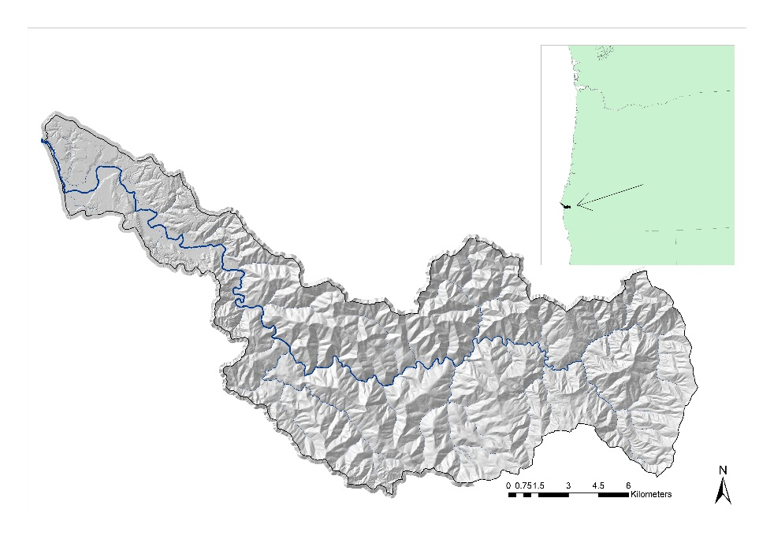
Figure 1. Location study area place holder.

3.0 Methods

3.1 NetMap’s Virtual Watersheds and Smart, Synthetic River Networks
A ‘virtual watershed’ is a computer-based geospatial simulation of riverine landscapes used to enumerate numerous aspects of watershed landforms and processes, and human interactions within them over a range of scales (Benda et al. 2015, Barquin et al. 2015). A LiDAR DEM, covering the lower one fourth of the watershed, was merged with a 10 m DEM to create a seamless DEM across the study watershed. NetMap’s virtual watershed contains six analytical capabilities that are required for Restoration Watershed Analysis in the Elk River basin: 1) delineating watershed scale synthetic river networks using the merged LiDAR and 10m DEMs (Figure 2), 2) connecting between river networks and terrestrial environments, and with other parts of the landscape, 3) routing of watershed information downstream (such as sediment) and upstream (such as fish), 4) discretizing landscapes and land uses into facets of appropriate scales to identify interactions and effects, 5) characterizing landforms and 6) attributing river segments with key stream and watershed information (Figure 2). A synthetic river network, derived from flow direction and accumulation, is comprised of a node based data structure, delineated at the scale of the composite 2 m DEM (Figure 2). From the nodes, individual channel reaches are created at a length scale that ranges between about 100 to 150 m (adjustable to any length scale during creation of the synthetic stream layer). To learn more about how NetMap’s virtual watershed and synthetic river networks are created, see NetMap’s online Technical Help.
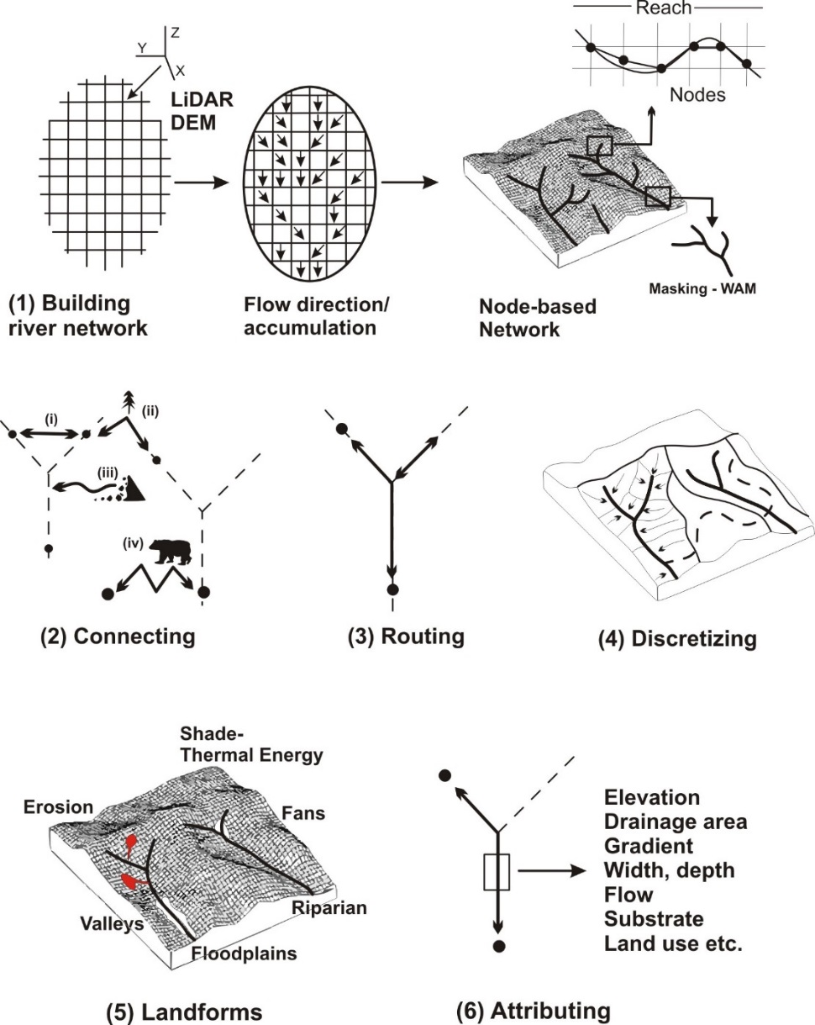

Figure 2. Analytical capabilities in the Elk River virtual watershed.

Modeling various forms of connectivity in a virtual watershed enables understanding of how landforms and processes interact with land uses. For example, each river node is linked to specific floodplain areas, thereby linking activities in floodplains to the reaches most affected. Predictions of heighted hillside erosion due to land use can be related directly to the channel reaches that would receive additional sediment. Using the Elk River virtual watershed, spatial patterns of processes and landforms, (e.g., aquatic habitats, slope stability, erosion-sediment supply, shade-thermal energy, floodplain extent etc.) and land uses ( e.g., roads, timber harvest, agriculture etc.) are aggregated downstream (or upstream) through the synthetic network, revealing cumulative (effects) patterns at any spatial scale defined by river networks (e.g., from the bottom of a first-order channel to the bottom of a seventh-order river).
A key element in a Restoration Watershed Analysis when evaluating interactions among watershed processes, landforms and land uses is the “drainage wing”, defined as the local contributing area to each channel segment. Drainage wings are used to transfer terrestrial information, such as upland and riparian vegetation, roads, and erosion potential, to stream reaches (Figure 3). Drainage wings are used to identify critical overlaps among reach scale attributes (~100 m length scale, or down to the 2-m resolution of LiDAR DEMs), such as fish-habitat potential, and watershed landforms (e.g., floodplains, erosion source areas), processes (e.g., road sediment delivery, pollutant spills), and land uses (e.g., roads, pipelines, timber harvest blocks, beetle-related tree mortality, engineered structures).

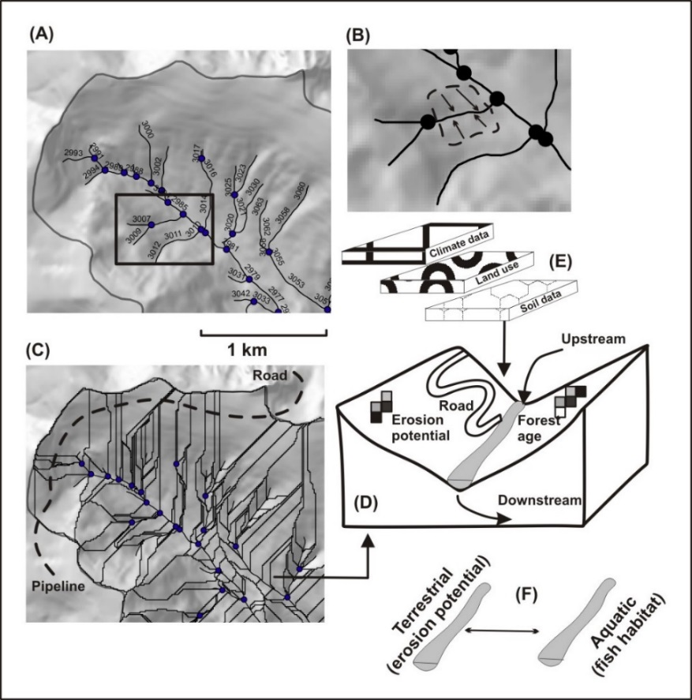
Figure 3. Drainage wings in a virtual watershed support numerous types of spatial analyses.

3.2 Attributes and Landforms in NetMap’s Elk River virtual watershed
NetMap’s Elk River virtual watershed contains more than 100 parameters derived from multiple analysis tools. Table 1 provides a sample listing of channel attributes and landform and process characterizations. For a full listing and discussion of all tools and parameters within NetMap, go to the online Technical Help.
Table 1. A partial list of channel attributes and landform and process characterization in the Elk River virtual watershed.
Channel Attributes | Landform and Process Characterization
Gradient | Floodplains
Elevation | Terraces
Distance to outlet | Alluvial fans
Drainage area | Hillslope-gradient and convergence (mass wasting)
Mean annual flow | Tributary confluences
Stream order | Erosion potential
Channel width and depth | Hillslope–slope profile
Bed substrate | Surface erosion
Channel sinuosity | Valley width and transitions
Channel classification | Debris flows
Fish habitats | Earthflows
Radiation loading | Floodplains
Mean annual precipitation | Terraces
Gradient | Riparian Processes

3.3 Analysis Tools Included in the Elk River-NetMap System
There are approximately 70 analysis tools that can be incorporated and used within Elk River Restoration Watershed Analysis (Table 2). There are 700 pages of online technical help that covers all current tools, their functions and example applications (see here).

Table 2. A listing of analysis tools available in NetMap’s system of virtual watershed and smart (synthetic) river networks. New tools will built and incorporated in the future.
NetMap Analysis Tools | 37) Westslope cutthroat habitat
Module: Analysis Tools | 38) Coastal cutthroat habitat
1) Define fish distribution | 39) Habitat diversity
2) Calculate channel gradients (multiple length scales) | 40) Cumulative habitat length and quality
3) Query watershed databases (n=5) | 41) Beaver habitat
4) Profile graphing (longitudinal and x-sectional) | 42) Channel disturbance index
5) Attribute aggregation, downstream – upstream, routing of buffer and hillslope attributes | 43) Piscidide tool
6) Google Earth zoom and map data transfer
7) Data management (n = 5) | Module: Riparian
8) Risk analysis (n = 2) | 44) Delineate variable width riparian zones
9) Sub-basin classification (n=2) | 45) In-stream wood recruitment, project scale
10) Watershed delineation | 46) In-stream wood recruitment, watershed scale
11) Construct drainage wings | 47) Upslope wood recruitment
 | 48) Thermal energy sensitivity
Module: Fluvial Processes | 49) Shade-thermal energy
12) Flow calculation | 50) Thermal refugia (4 types)
13) Mean annual flow
14) Stream power | Module: Erosion
15) Bankfull flow | 51) Hillslope gradient
16) Channel width | 52) Shallow landsliding
17) Channel depth | 53) Debris flows
18) Flow velocity | 54) Flash floods
19) Bed shear stress/D50 | 55) Gully erosion
20) Channel sinuosity | 56) Earthflow/deep seated
21) Reach gradient adjustment | 57) Convert to sediment yields
22) Maximum downstream gradient | 58) Sediment delivery adjustment
23) Drainage area | 59) Hillslope gradient
24) Stream order
25) Stream power | Module: Roads
26) Tributary confluence effects | 60) Import road layer
27) Valley width | 61) Road density – basin scale
28) Azimuth | 62) Road density – channel segment scale
29) Channel classification (4 types) | 63) Road hydrologic connectivity
30) Drainage and tributary junction density | 64) Road erosion and sediment delivery (n = 3)
31) Valley floor elevation mapping | 65) Optimized drain locations
32) Floodplain mapping | 66) Optimized road surface erosion remediation
33) Landslide – channel interactions | 67) Road stability
34) In-stream wood accumulation types | 68) Roads in floodplains
 | 69) Habitat upstream of crossings
Module: Aquatic Habitats
35) Create aquatic habitats (HIP model builder) | Module: Wildfire/Climate change
36) Bull Trout habitat | 70) Wildfire Cascade
 | 71) Climate change vulnerability

3.4 Multiple Scales of Analysis in Support of Restoration Watershed Analysis
A key element in the NetMap’s Restoration Watershed Analysis is the ability to examine land-use, landform, and process interactions over multiple spatial scales that include: 1) DEM pixel scale (e.g., such as erosion potential), 2) stream segment scale, nominally 100 m length scale, but can be adjusted ranging from the grain of the LiDAR DEM (1 m) and upwards during creation of the synthetic stream layer, 3) buffer scale, such as vegetation patches and riparian zones, 4) hillside drainage wings (stream reach local contributing area, approximately 0.1 km² associated with 100 m stream segments), 5) terrestrial and channel reach information aggregated downstream (or upstream) at any spatial scale defined by the channel network (e.g., bottom of a first-order stream to the bottom of a seventh-order river), 6) linear features, such as road or pipeline networks, broken at pixel-cell boundaries (1 m) and then re-aggregated to any length scale to support various analyses, such as road hydrologic connectivity, road surface erosion, and pipeline infrastructure, and 7) watershed and land use data can be summarized at the scale of sub-watersheds of various scales (Figure 5).
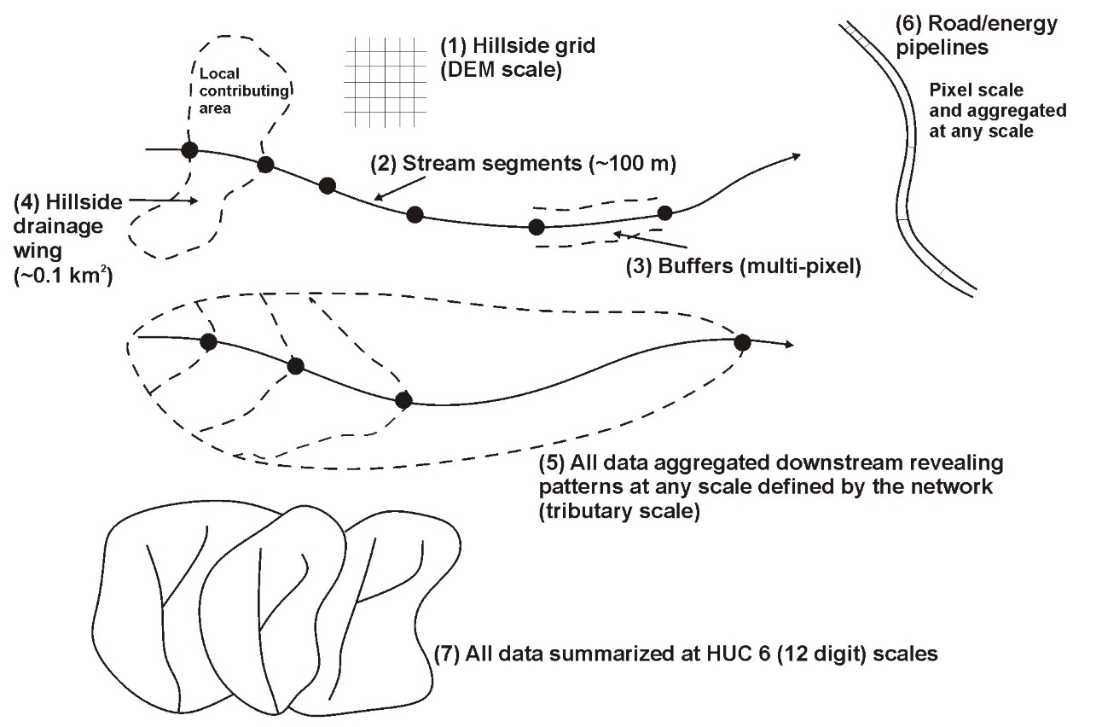
Figure 4. Multiple scale of analysis within the Elk River-NetMap Restoration Watershed Analysis.

4.0 Analysis Results

4.1 Valley Floor and Floodplain Ecosystems
NetMap’s valley floor mapping tools were used to map the elevations and diversity of the floodplain ecosystem, including of Elk River mainstem and lower portions of tributaries. Estimates of bankfull channel depth are required to map floodplains and terraces in measures of multiples of bankfull depths. We applied the bankfull width and depth regressions used in Clarke et al., 2008), where bankfull channel depth = 0.328 * (drainage area in km²)^{0.252} and where bankfull channel width = 10.7 * (mean annual flow, in CMS)^{0.4}. The predicted generalized (e.g., statistically smoothed) channel widths ranged from 32 m to 36 m in the lower mainstem (Figure 5). Predicted widths approximately matched actual channel widths as measured on Google Earth in the lower, unconfined (visible) portion of the Elk River mainstem. There is large variability in channel widths observed on Google Earth, and this variability is not captured in statistical regressions. Bank full channel depths in the lower mainstem are predicted to be 1.2 m to 1.3 m. Field measurements of bankfull channel depth (averaged over many locations in the thalweg) would be required to validate them.
If local data were available on bankfull depths and widths, more accurate statistical regressions could be developed and applied; however, this would require measurements that span the full range of basin drainage areas (headwaters to mainstem). In addition, if local measurements were available in select areas, they could be used to adjust reach scale values in the reach attribute table in ArcMap-NetMap. Then, the floodplain mapping tool could be rerun.
One task is to determine, particularly for the lower mainstem river, the absolute surface elevations and surface levels classified by multiples of bankfull depths that are associated with floodplains. Floodplains classified by multiples of bankfull depth accounts for the effects of channel size (width, depth) on floodplain elevations and extents (Dunne and Leopold 1978, Rosgen 1996). The analysis is challenging because many floodplains in the lower river have likely been converted to agricultural land. Nevertheless, we used a combination of NetMap’s floodplain elevation and classified surface levels (e.g., multiples of bankfull depths), cross sectional profiles (across the valley floor) and Google Earth images to identify provisional floodplain surfaces along the lower mainstem river; our findings would also apply to floodplains located anywhere in the watershed.

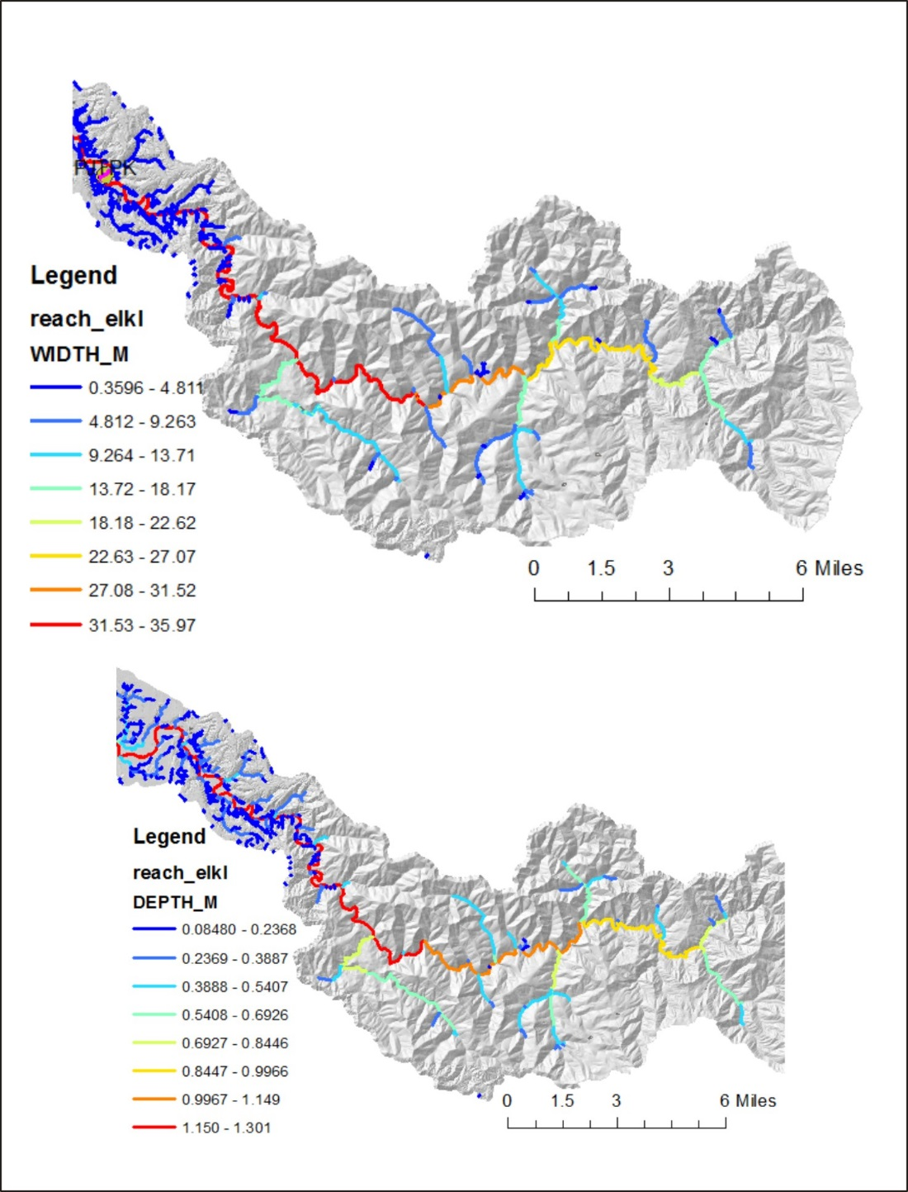
Figure 5. Statistical regressions from Clarke et al. (2008) were used to predict bankfull channel widths and depths.

Our analysis was conducted at three locations (Figures 6 to 9). Although the historically active floodplain is obscured in most locations by land use activities (primarily agriculture), the cross-section data that reveals floodplain features (side channels, oxbows, splay deposits and levees) are used to identify the elevations of naturally occurring floodplains. The locally higher elevation areas immediately adjacent to the channel, called levees, may either be natural features or engineered; Figure 6 shows a levee that might be engineered and Figure 8 shows one that might have natural origins. Apparent remnants of a side channel (B on floodplain map) corresponds to a depression in the cross-sectional profile.
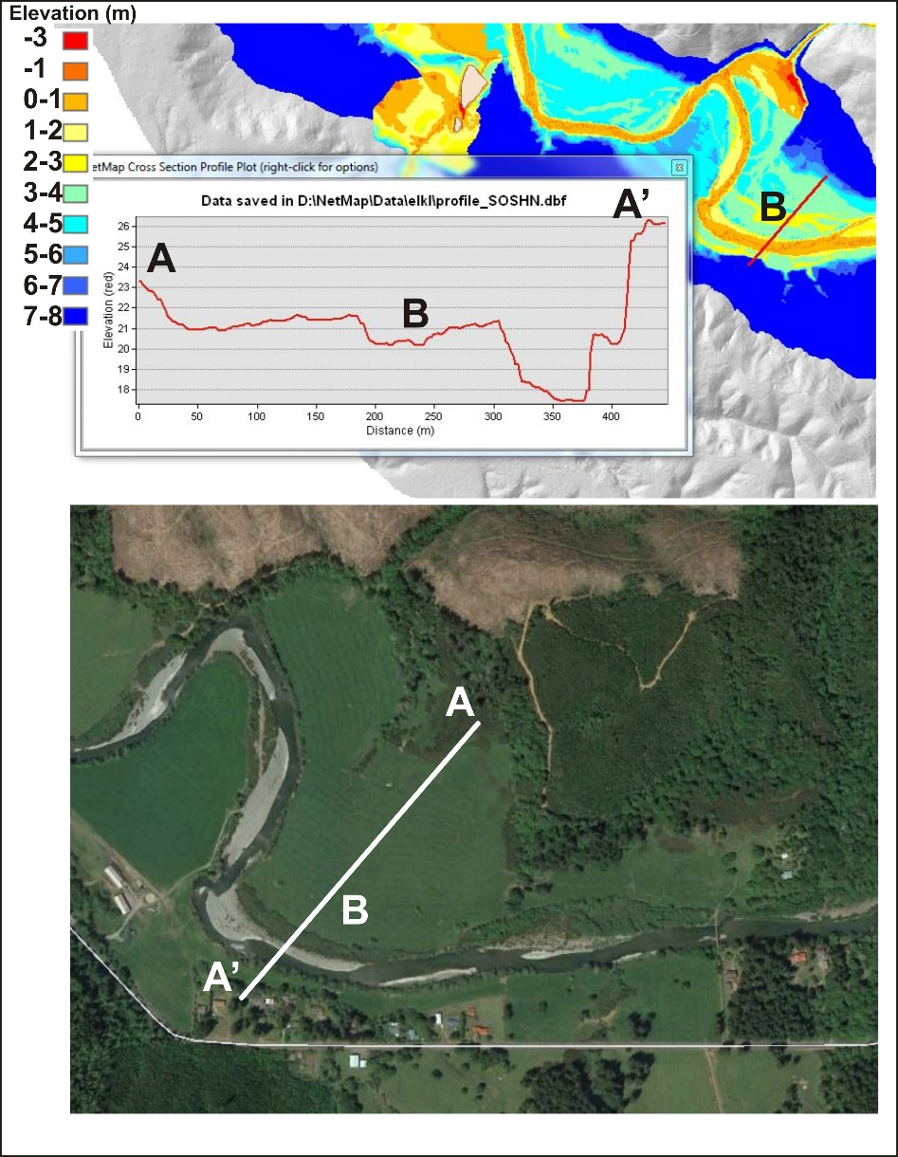
Figure 6. (upper) Valley floor surface elevations and a cross sectional profile (A-A’), along with a Google Earth image of the same area. Apparent remnants of a side channel (B on upper floodplain map) corresponds to a depression in the cross-sectional profile.
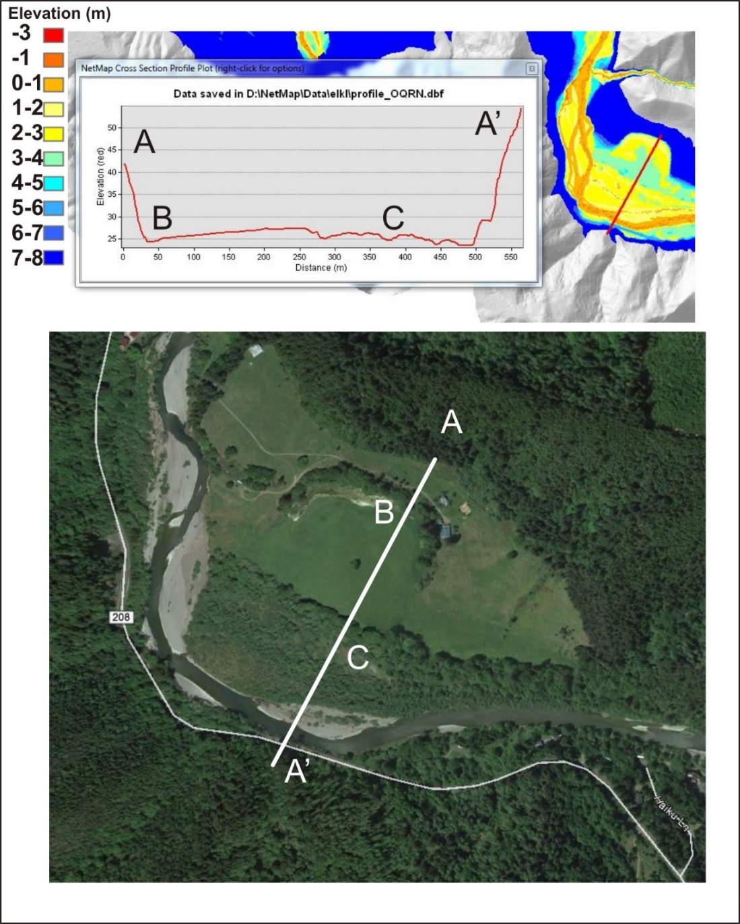
Figure 7. (upper) Valley floor surface elevations and a cross sectional profile (A-A’), along with a Google Earth image of the same area. “B” appears to represent an abandoned oxbow lake and “C” appears to represent active floodplain (flooding area). The active floodplain area is 2 to 3 meters above the channel.

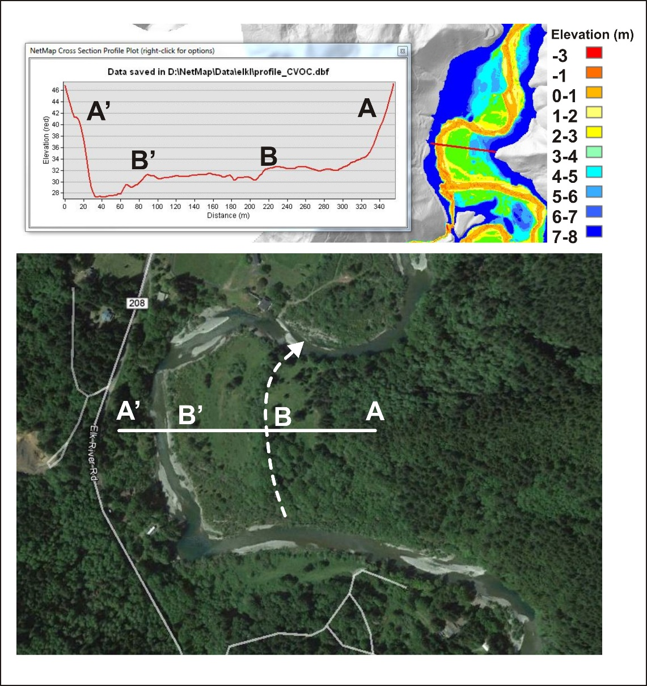
Figure 8. (upper) Valley floor surface elevations and a cross sectional profile (A-A’), along with a Google Earth image of the same area. “B” appears to represent a side channel, with the area between B and B’ representing an active floodplain.
Our analysis indicates that natural floodplains along the lower mainstem of the Elk River may occur at three to four meters above the channel elevation (in the LiDAR DEM), with areas 3 meters being more frequently flooded and areas 4 meters being less frequently flooded (Figures 6 to 8). However, land use conversion of floodplains has likely reduced flooding potential. These elevations correspond to one through three multiples of bankfull depth floodplain elevation classes (Figure 9), with 2x bankfull depth surfaces being more frequently flooded and 3x bankfull depth being less frequently flooded. Most of the largest areas of predicted floodplains appear to have been converted to agricultural areas (Figure 10). The floodplain analysis will be coupled to predictions of habitat intrinsic potential to identify areas of potential channel/floodplain restoration.
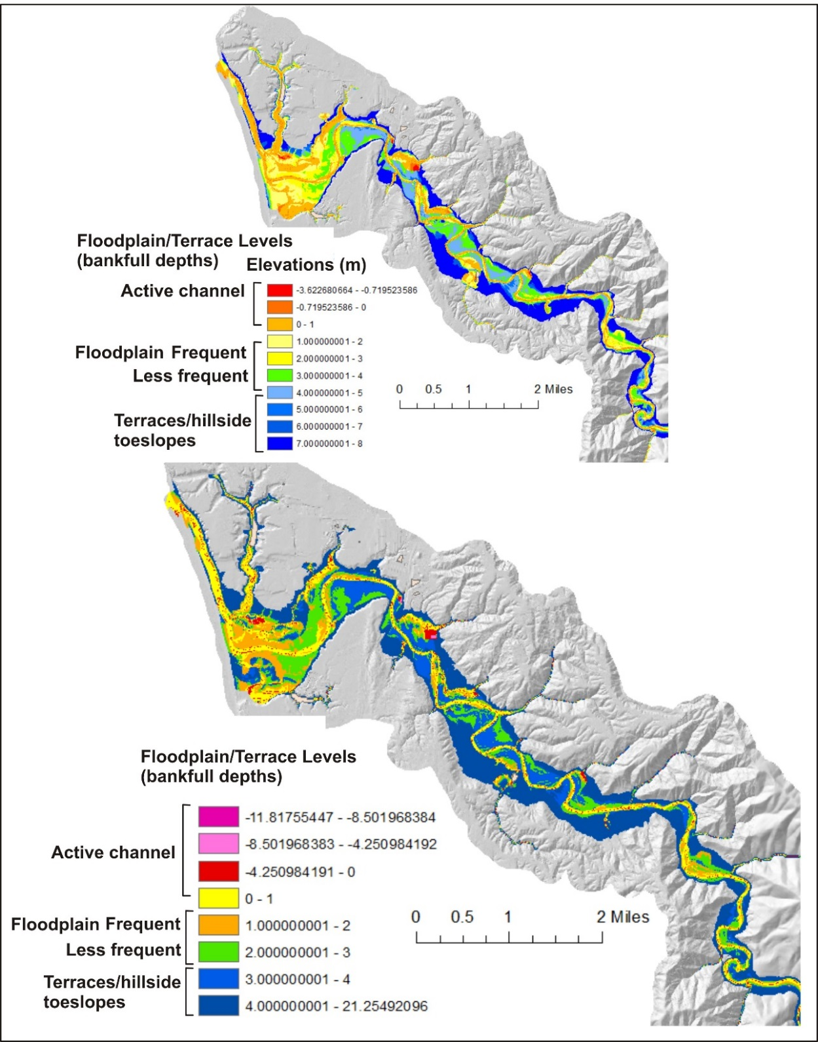
Figure 9. Classification of floodplains. Valley floor elevations (upper) and in multiples of bankfull depth (lower) along the lower mainstem of the Elk River watershed.

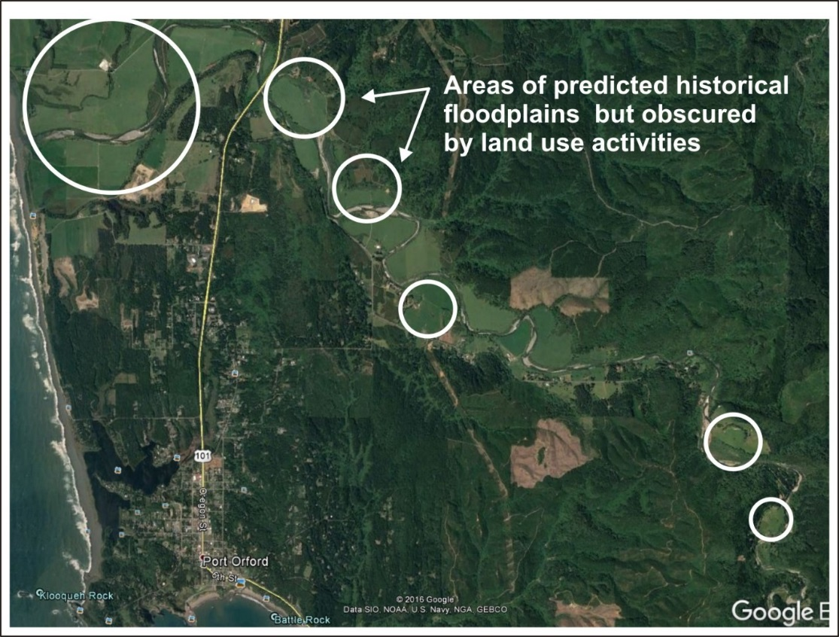
Figure 10. Likely areas of floodplain conversion (and abandonment) based on NetMap’s floodplain analysis (Figures 6 to 9).

4.2 Fish and Beaver Habitats
The habitat intrinsic potential (HIP) model of Burnett et al. (2007) was applied in the Elk River to identify preferred habitats of coho and Chinook salmon, and steelhead. The HIP model uses channel gradient, channel confinement (valley width divided by channel width) and mean annual flow; values range from zero to one, with higher scores equaling better intrinsic habitats.

The best predicted coho salmon habitat in the Elk River (IP scores > 0.75) is located in the lower part of the watershed, in the area with the widest floodplains and unconstrained valley floors (Figure 11). Moderate habitat suitability for coho (IP 0.5 to 0.75) extend throughout the upper mainstem and into the lower portions of the largest tributaries (Figure 11). However, some of the highest potential coho habitat quality overlap areas in the lower watershed with diminished floodplains (Figures 9 and 10).
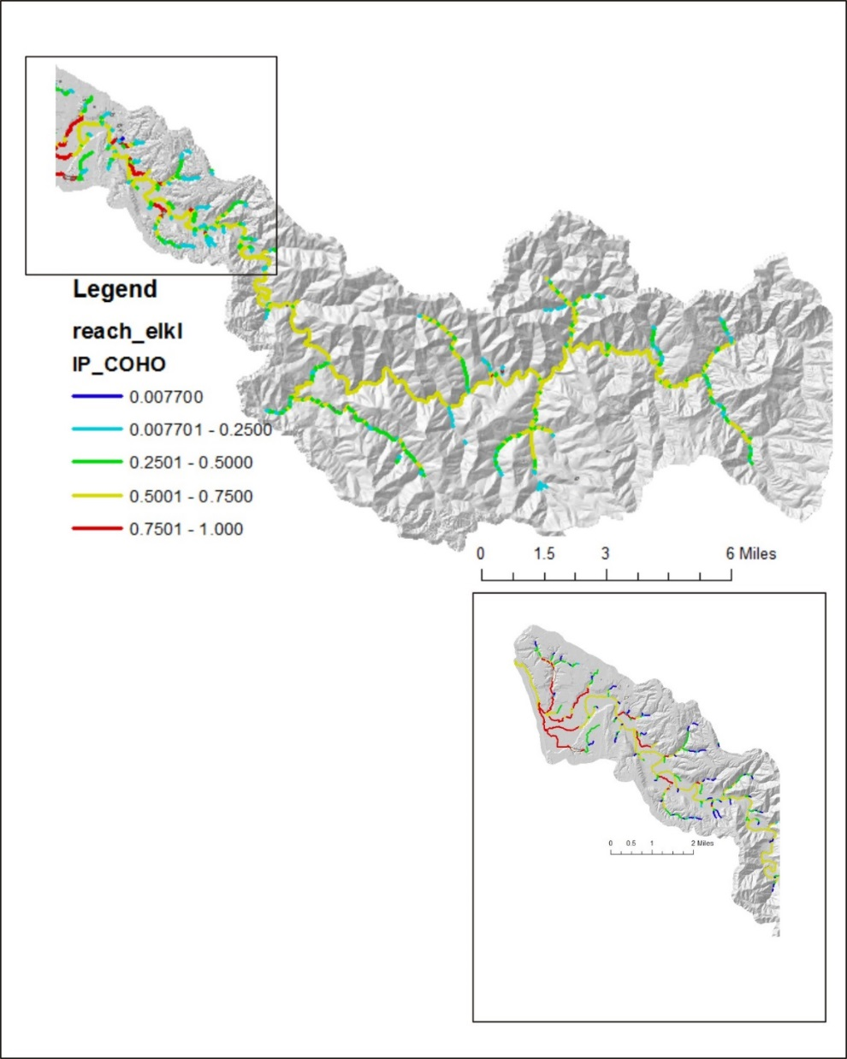
Figure 11. Habitat intrinsic potential for coho rearing habitat.

The best predicted steelhead habitat is located throughout the upper watershed and into the lowest portions of the largest tributaries (Figure 12). To some extent, the maps of coho and steelhead IP values are reversed, because steelhead prefer somewhat steeper and more confined channels compared to coho. Chinook habitat is predicted to have moderate quality throughout the mainstem and into the largest tributaries of the Elk River watershed (Figure 13).

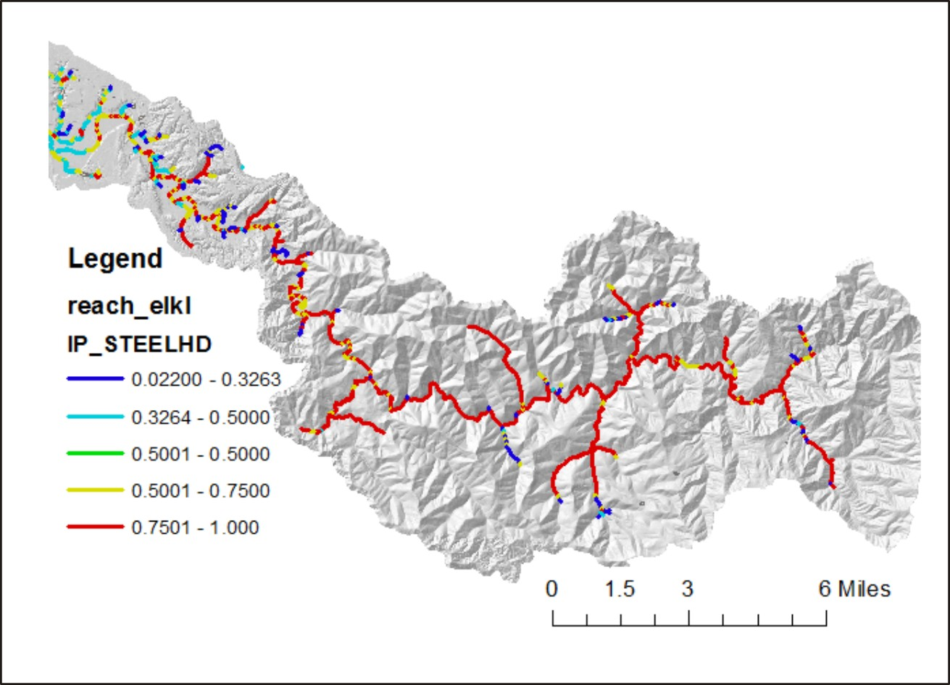
Figure 12. Habitat intrinsic potential for steelhead rearing habitat.

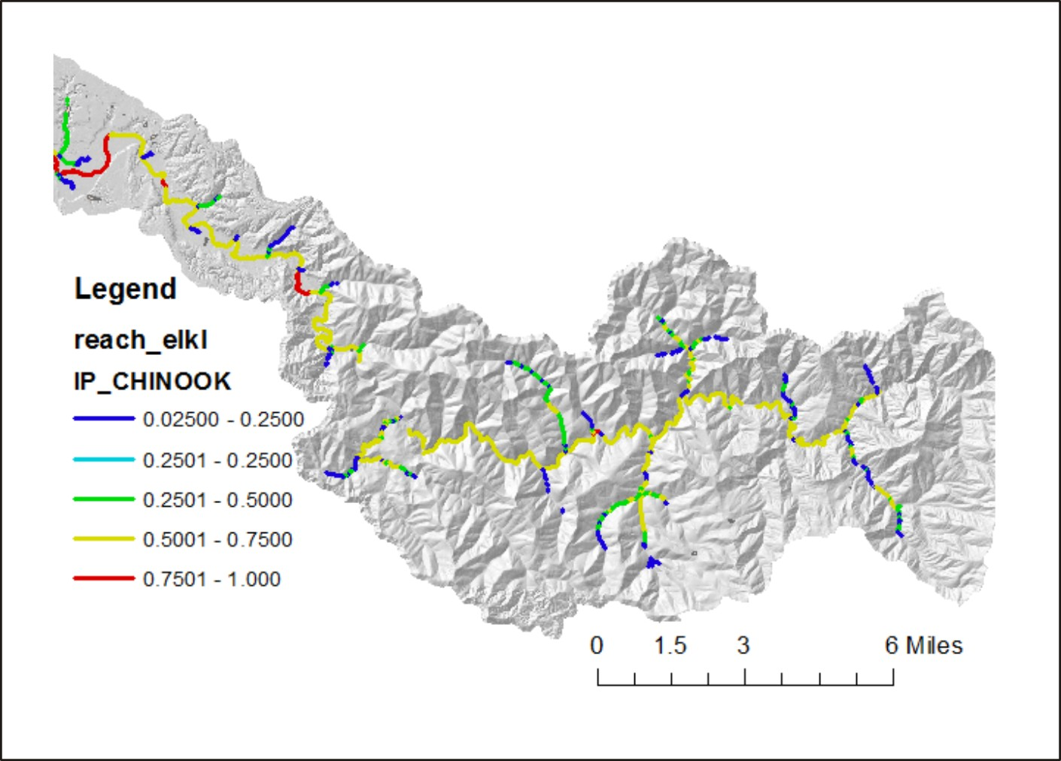
Figure 13. Habitat intrinsic potential for chinook rearing habitat.

The habitat intrinsic potential model predictions are only approximations of the spatial extent and quality of fish habitats. Field validation of salmon and steelhead spawning extent would provide a more accurate picture of the spatial distribution of the different species. Estimates of salmon and steelhead distributions (Oregon Department of Fish and Wildlife, draft in 2001, from the Elk River Watershed Assessment [2001]) is shown in Figure 14. The HIP models over-predict fish distribution in some areas, and under-predict it in other areas. However, the ODFW distribution may not be comprehensive in the smaller tributaries (ERWA 2001).

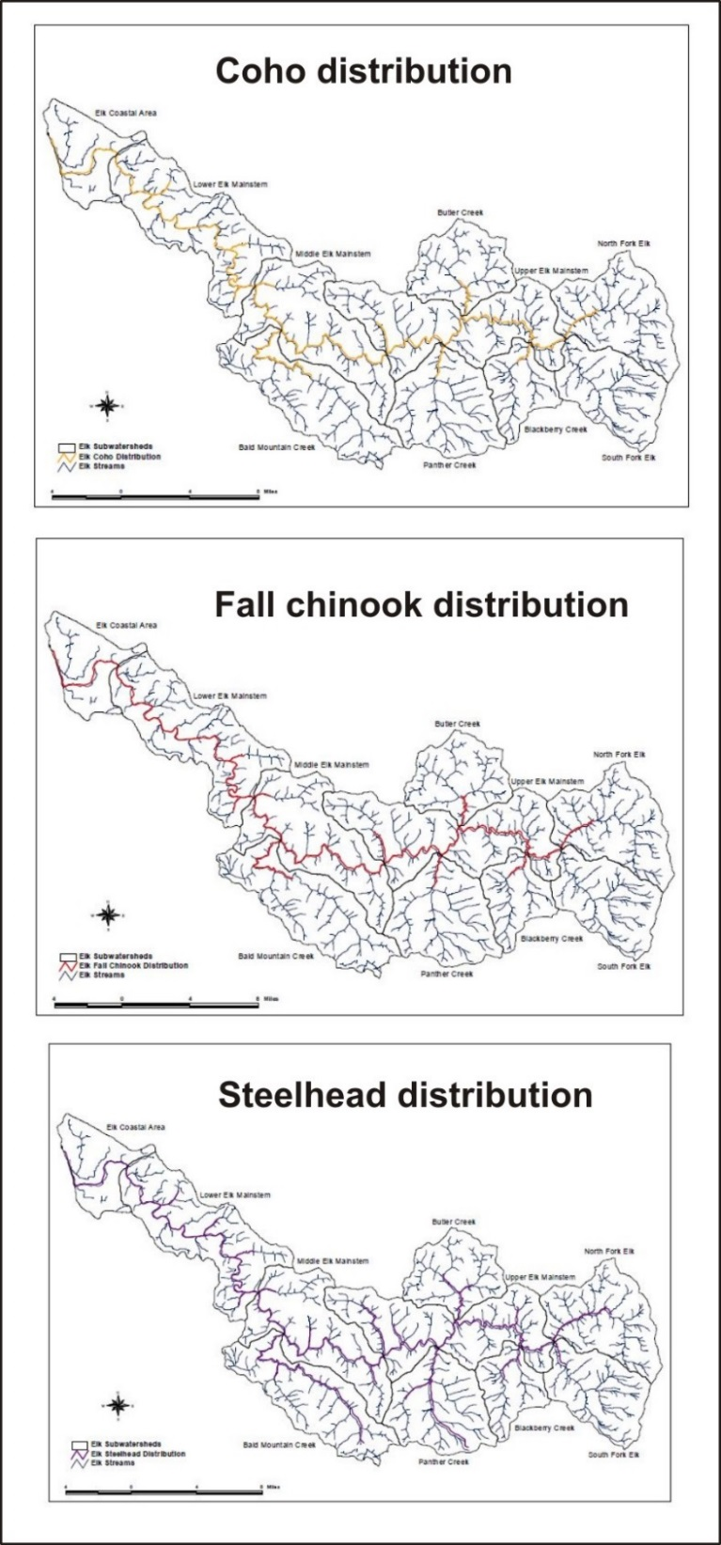
Figure 14. Estimates of fish distribution from Oregon Department of Fish and Wildlife (obtained from Elk River Watershed Assessment [2001]).

Beaver habitat was predicted using NetMap based on the model of Pollock et al. 2004. The model applies channel gradient, drainage area and stream power thresholds. The model predicts that the lower mainstem and tributaries were prime beaver habitat, although the mainstem river is probably too large and swift to support dam building (Figure 15). But the lower tributaries that extend onto the floodplains (historically) likely provided extensive beaver habitat.

Habitat predictions for westslope cutthroat and coastal cutthroat trout are not included in this report. Analysts are referred to the complete Elk River – NetMap datasets and tools to examine model predictions for resident species.

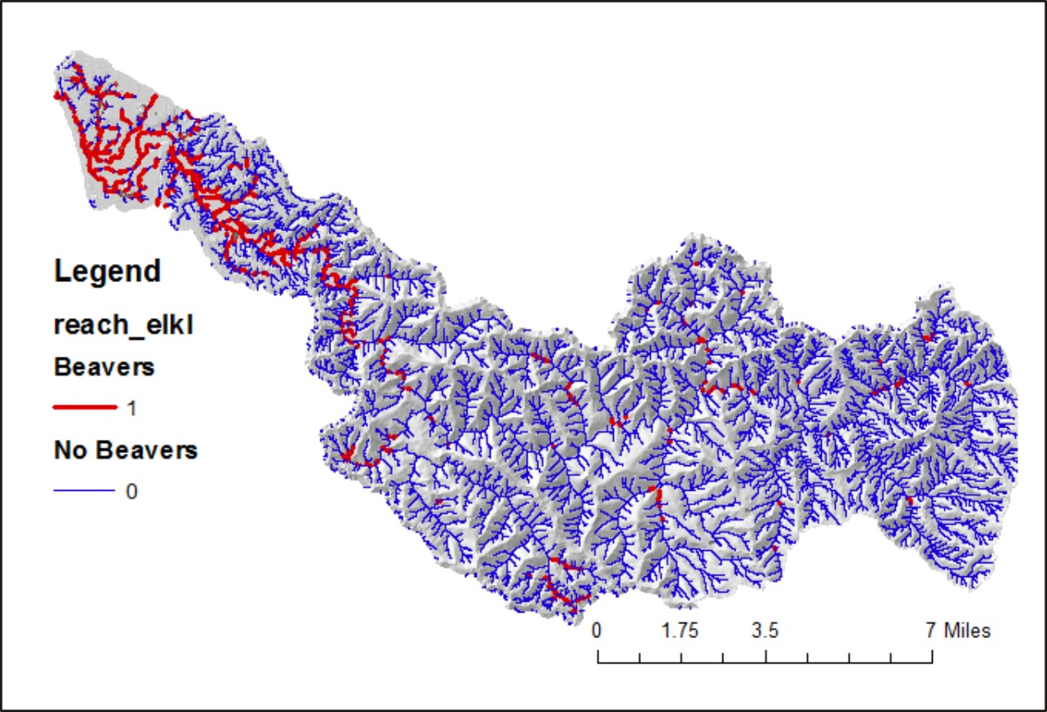
Figure 15. Predicted beaver suitable habitat in the Elk River watershed.

4.3 Riparian Analysis

Thermal Energy to Streams/ Stream Shading
NetMap tools were used to estimate the thermal energy load to the channel network in the Elk River basin, in the absence of vegetation (but taking account of latitude, solar angle, channel orientation, channel width and topographic shading); NetMap’s “Bare Earth” thermal prediction is equivalent to “Solar Potential” in Oregon’s DEQ Heat Source Model. NetMap tools were also used to predict thermal load given full forest vegetation canopy (assumed 200 foot tree height, vegetation density of 0.7 [dense] and an unlimited width of riparian forests, in watt-hours m⁻²); NetMap’s predicted “Vegetated Solar Radiation” is equivalent to “Solar Received” in Oregon’s DEQ Heat Source Model. Solar received minus bare earth radiation provides one measure of the sensitivity of removal of vegetation on thermal load to the stream and consequently on potential stream heating (Figure 16). For additional technical background on NetMap’s thermal tool, go here.

There are concentrated zones where removal of streamside vegetation, either by logging or fire, would lead to significant increases in thermal load. Many of these areas are in headwaters with western or southern exposure (Figure 16). For anadromous fish bearing streams only, channels with the highest potential for increases in thermal loading are located in the small tributaries in the lower river (Figure 16).
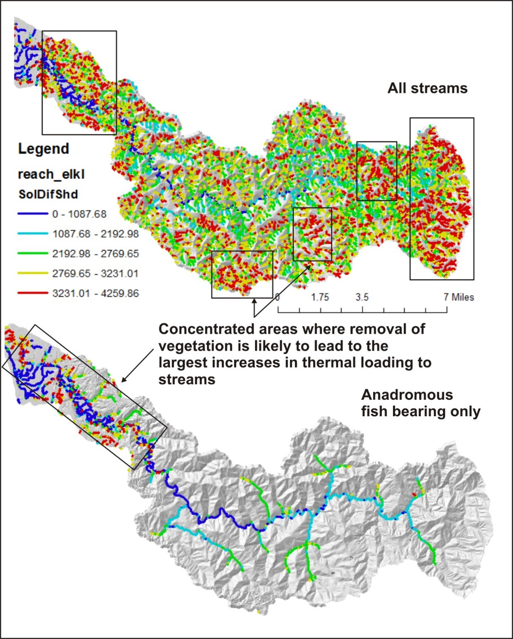
Figure 16. Thermal loading sensitivity analysis identifies areas where removal of streamside vegetation will lead to higher thermal loading.

NetMap also contains another tool for predicting shade-thermal loading conditions to streams based on existing riparian vegetation conditions. A shade model is applied that requires tree height and basal area (Groom et al. 2011); for additional information, go here. Existing vegetation conditions in the Elk River watershed is obtained from LEMMA. Maps of stand height (computed as an average of all dominant and co-dominant trees, in meters) and basal area (basal area of all live trees greater than 2.5 cm in diameter, in terms of m²/ha) are shown in Figure 17. LEMMA data indicate that there is a large diversity of basal area and stand heights, including many areas of larger values, in the upper watershed, an area dominated by larger conifer trees and little logging history (including a wilderness area). The smallest tree heights and lowest basal area (including lack of forest vegetation) are concentrated in the lower river mainstem and adjoining tributaries, the area of concentrated agricultural activities (Figure 17).

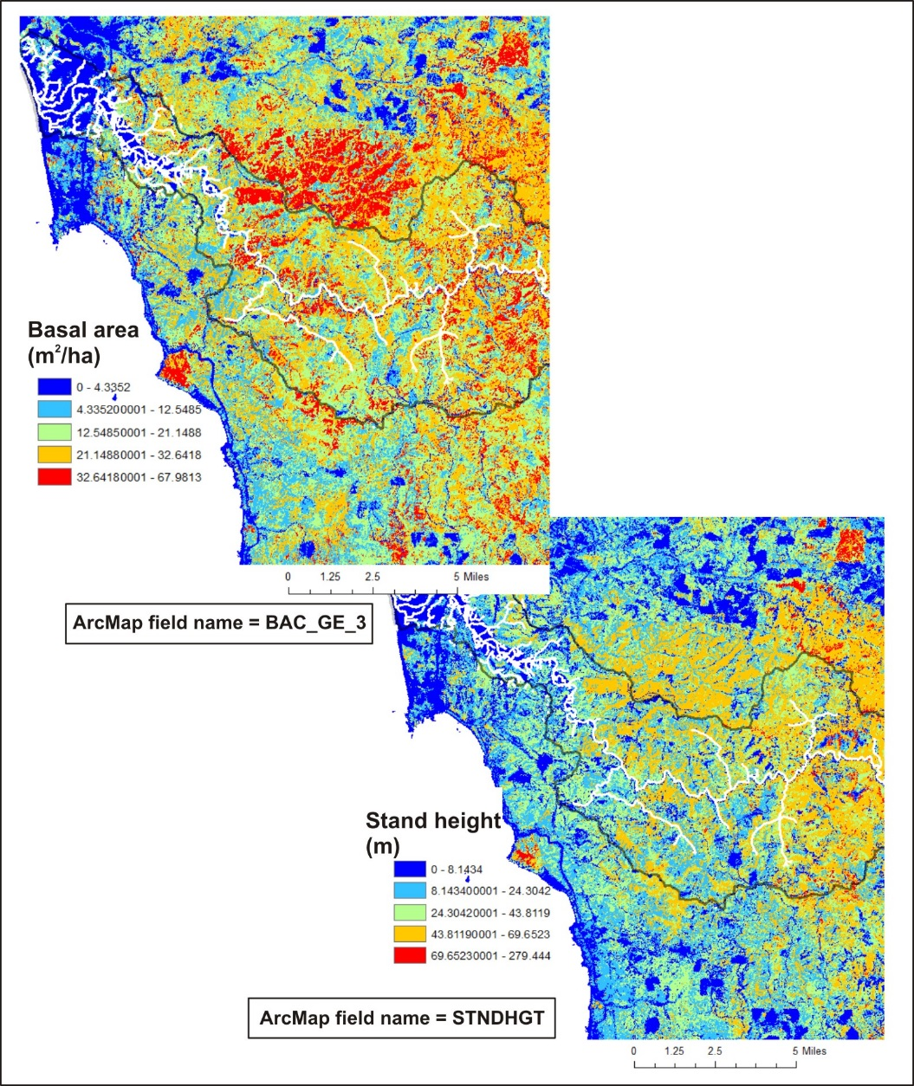
Figure 17. Vegetation characteristics from LEMMA used in NetMap’s shade-thermal energy model.

Predicted current shade effects on thermal loading closely follow LEMMA maps of tree height and basal area. Thus, the channel segments with the lowest shade and highest predicted thermal loading are concentrated in the lower mainstem river (Figure 18). NetMap’s tools allow an analyst to simulate ideal shade conditions in a watershed and to recalculate thermal loading to streams. By subtracting existing shade-thermal loading from idealized shade-thermal loading, one can identify where, in a watershed, additional streamside shade would be most effective. This was done in the Elk River watershed using a maximum tree height and basal area (approximately the 90th percentile of tree heights and basal area in the LEMMA data within the Elk River watershed). Results are shown in Figure 19.
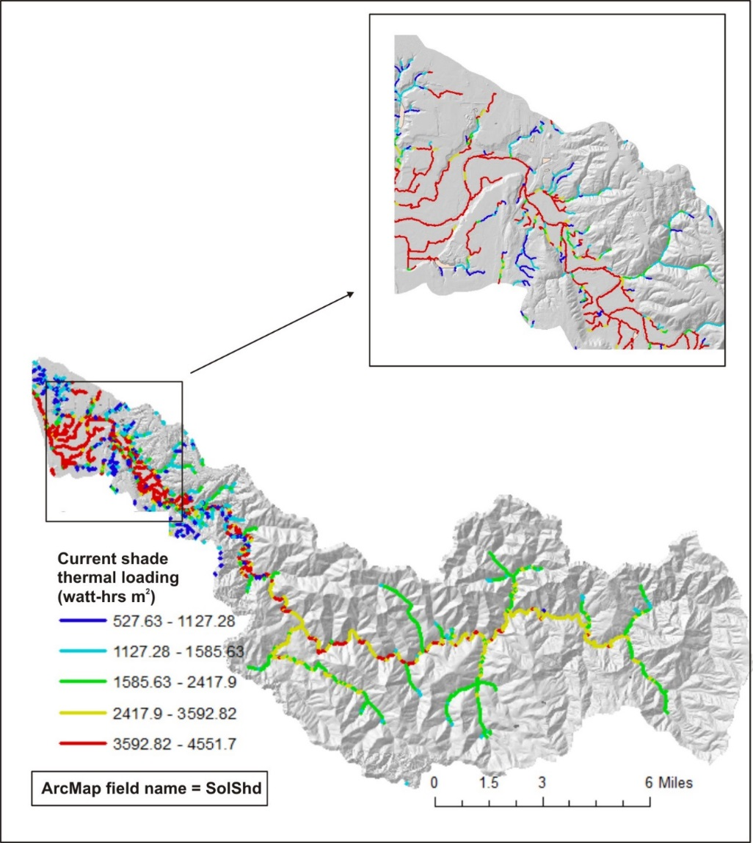
Figure 18. Current shade and thermal loading using vegetation data from LEMMA, showing fish bearing (anadromous) streams only.

The channel segments with the greatest positive effect from adding shade (e.g., reducing thermal loading) are concentrated in the lower mainstem river floodplains (including those that have been abandoned, see earlier) (Figure 19). Note that the largest and widest channels, specifically the Elk River mainstem, are not identified as having a significant positive effect from adding shade. This is because the wide channels receive the majority of their thermal energy from the sky view above the channel, and streamside shade does not contribute significantly to net thermal loading. The channels identified to gain the most from additional shade are the small tributaries located on the wide valley floors (including converted floodplains) (Figure 19).
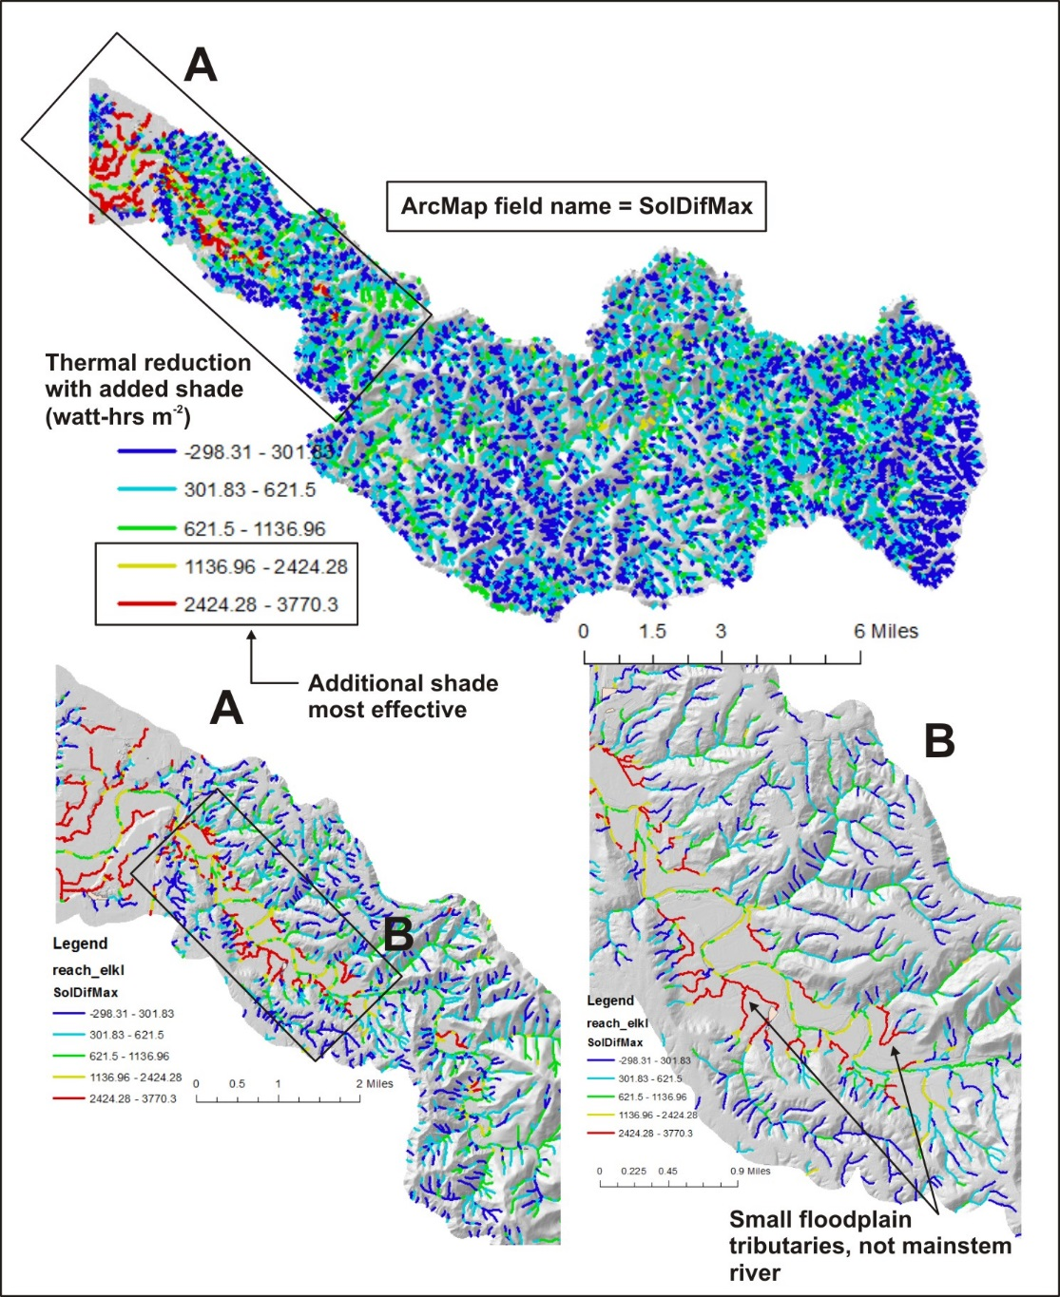
Figure 19. Where additional shade would be most effective.

In-stream wood
NetMap contains a tool for predicting a single year (current year) in-stream wood loading based on existing riparian forest conditions (using LEMMA vegetation data). The model applies a wood budgeting approach and considers forest stand density (of different diameter classes), width of the riparian forests, random or non-random tree fall trajectories, distance of trees from the stream edge, tree taper and channel width (Benda and Sias 2003). For additional information about the wood recruitment tool in NetMap, see here.

One of the main drivers of in-stream wood is the riparian tree sizes. This can be represented by the average quadratic mean diameter of stands, data available from LEMMA (Figure 20). There are numerous areas of larger trees located in the upper one half of the watershed, particularly located north of the mainstem. Most of the large tree areas are located within the national forest boundary and in the wilderness area (Figure 20). Areas of the smallest forest vegetation are concentrated in the lower one-third of the watershed, in areas of private forest land. Notably, there are extensive areas of no trees (zero quadratic mean diameter in Figure 20) located all along the wide valley floors and floodplains (including floodplains converted to agricultural lands) in the lower valley.
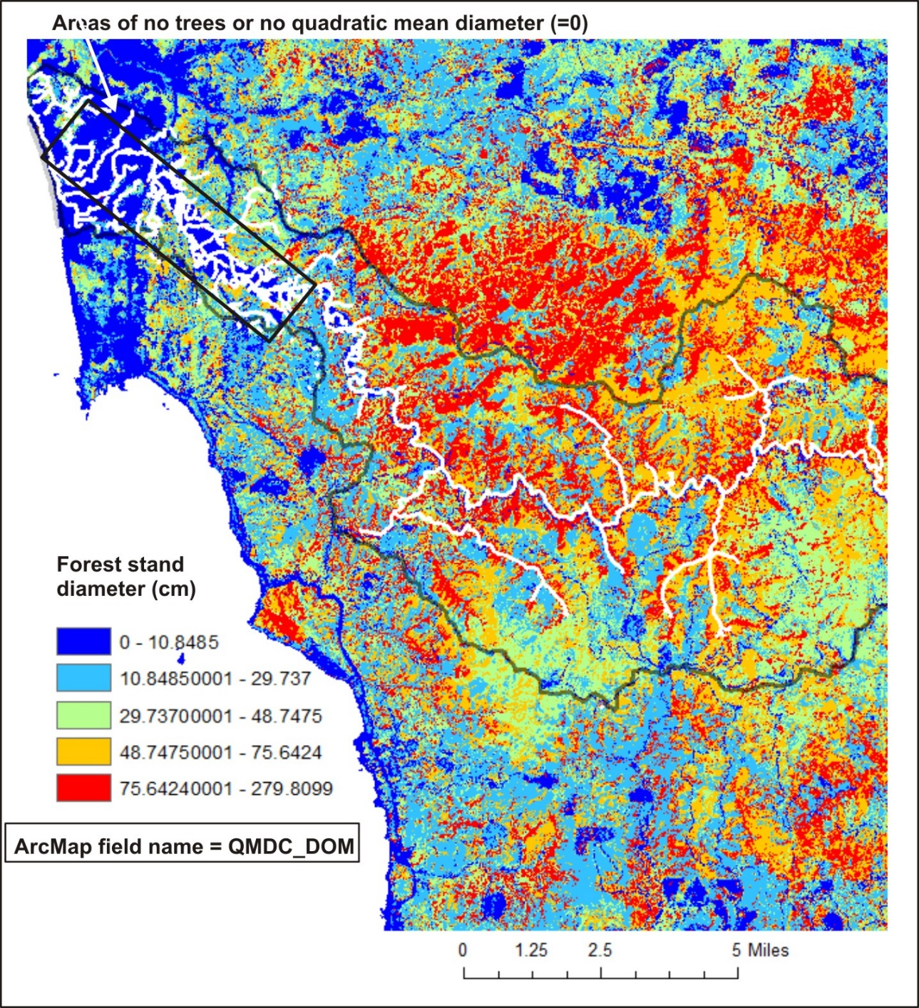
Figure 20. Vegetation information from LEMMA, used to characterize the current (single) year in-stream wood recruitment potential.

Consequently, there are numerous stream channels located in the upper two thirds of the watershed, including the mainstem and larger tributaries, that are predicted to have high levels of large (> 50 – 100 cm) in-stream wood (Figure 21). This is due to extensive national forest land with minimal history of intensive logging. The lower mainstem river and adjoining tributaries located along the wide valley floor, including historical floodplains, have the lowest in-stream wood, including no instream wood.

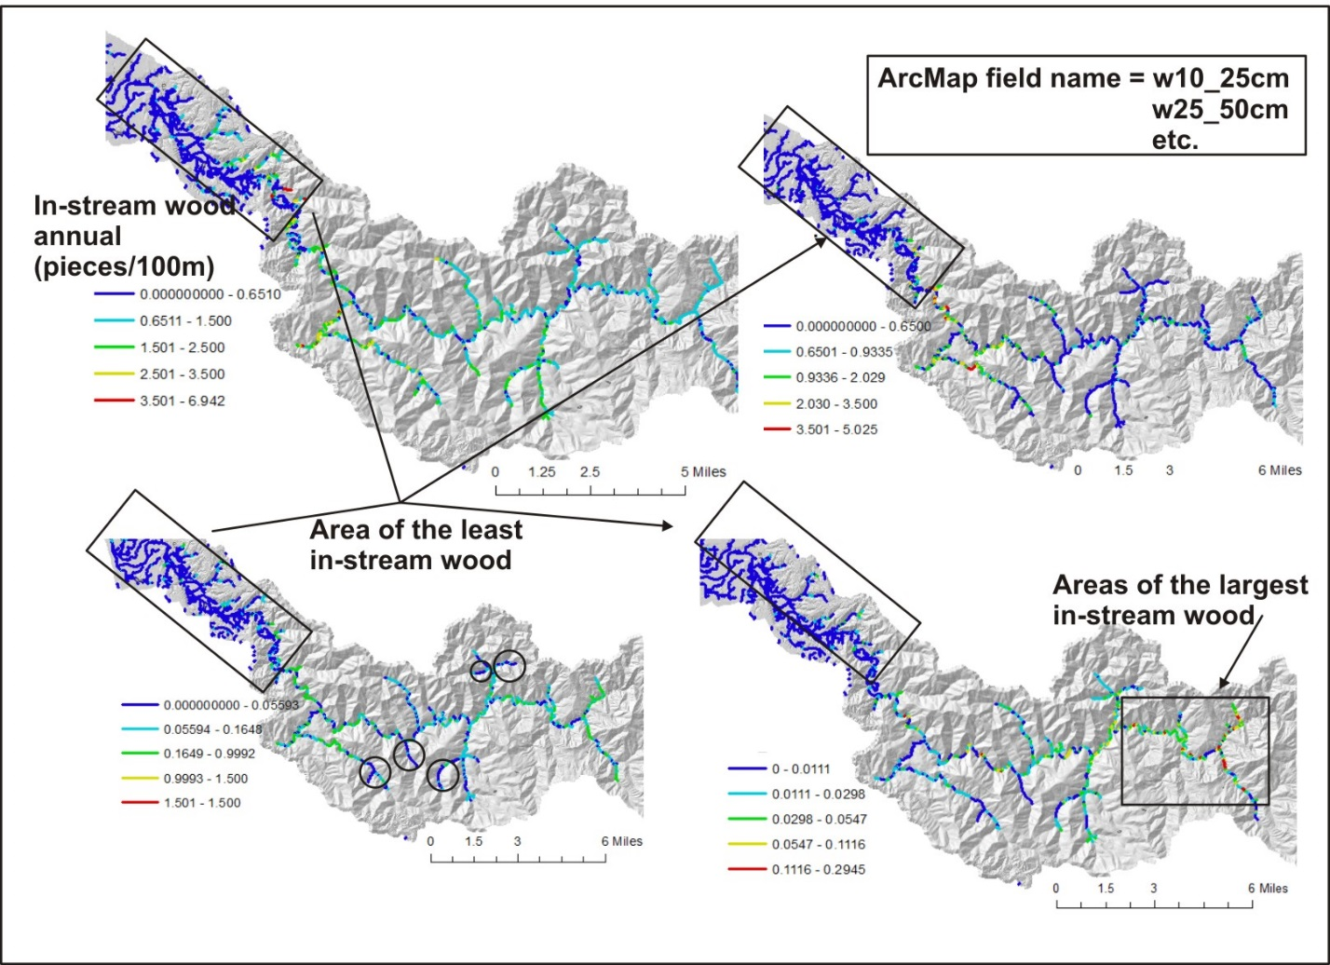
Figure 21. NetMap was used to predict the current (single) year in-stream wood recruitment potential across four-piece diameter classes.

Thermal Refugia
Thermal Refugia within streams is important for certain aquatic life, including endangered fish species such as salmon and trout. Thermal refugia is particularly important in watersheds that have less than optimum shade conditions because of historical and current land use including forestry, agriculture and urbanization. In addition, climate change that decreases summer stream flow or increases stream temperatures can exacerbate warm water conditions, making thermal refugia even more important.

Thermal refugia is best determined by field surveys of stream temperatures in the summer, but obtaining temperatures at the watershed scale can be expensive and time consuming. Another method is airborne thermal remote sensing which requires aircraft (fixed wings or helicopters) to fly over sections of rivers and document water temperature (Torgersen et al. 2001). Airborne thermal remote sensing holds great promise to obtain actual water temperature conditions, including identifying thermal refugia, however, it continues to be difficult (and expensive) to apply at the scale of large watersheds, landscapes and states. Another approach is to use intrinsic landscape conditions on thermal loading to streams, combined with current shade conditions, to map potential thermal refugia. NetMap contains a tool to map four types of provisional thermal refugia: 1) along channel (reach scale), 2) cumulative channel (tributary scale), 3) confluence intersections with mainstems, and 4) floodplain upwelling.

Reach scale (100 m +/-), tributary scale and confluence scale provisional thermal refugia (cooler water conditions) are shown in Figures 22 through 24. For additional information on NetMap’s thermal refugia tools, see here.
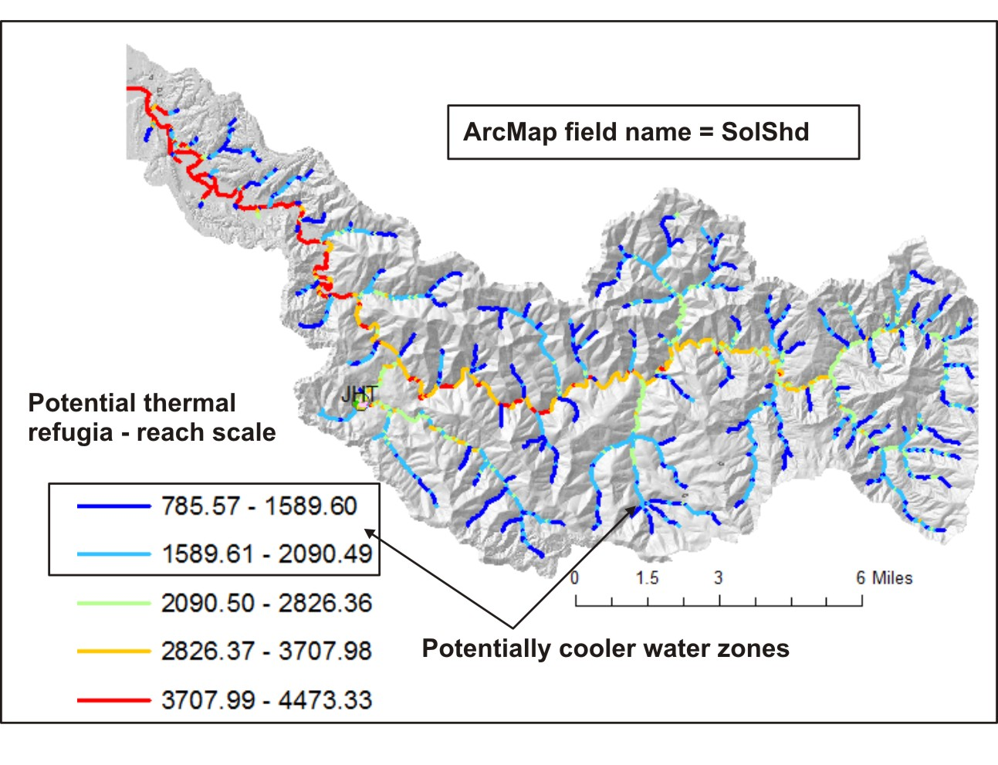
Figure 22. NetMap was used to predict potential reach scale cooler water conditions.

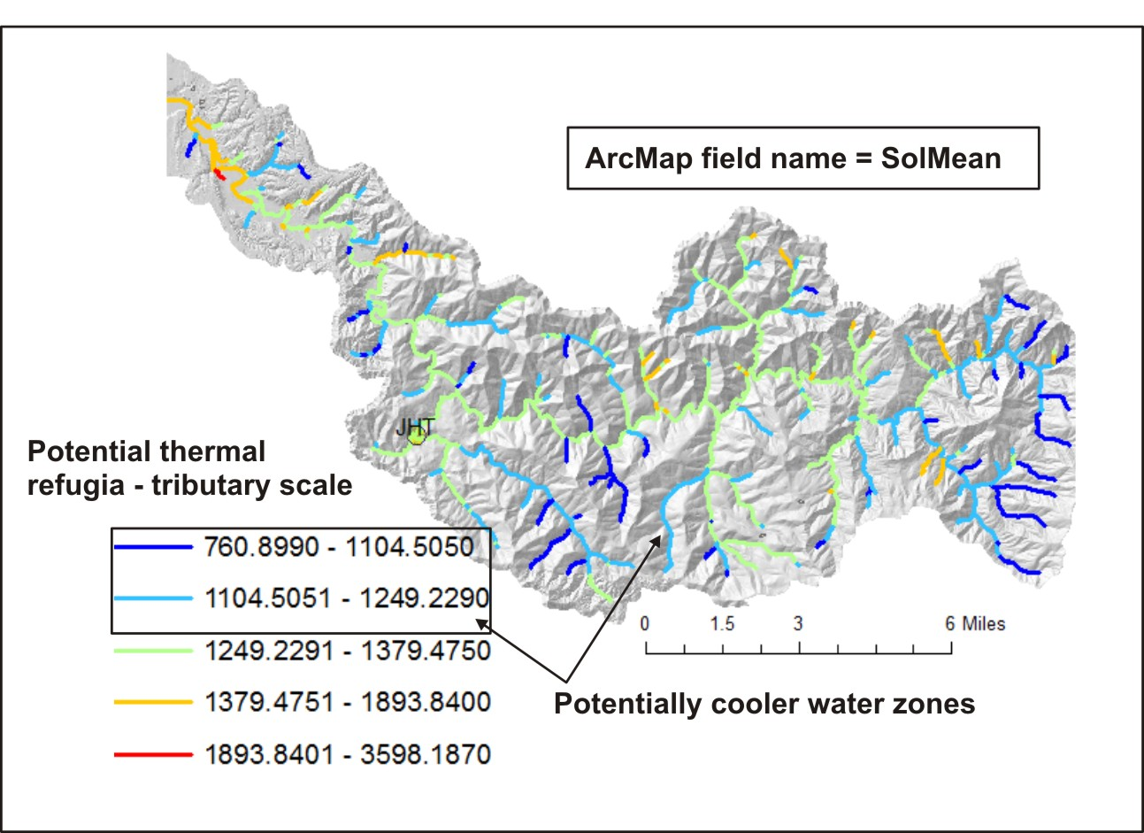
Figure 23. NetMap was used to predict potential tributary scale cooler water conditions.

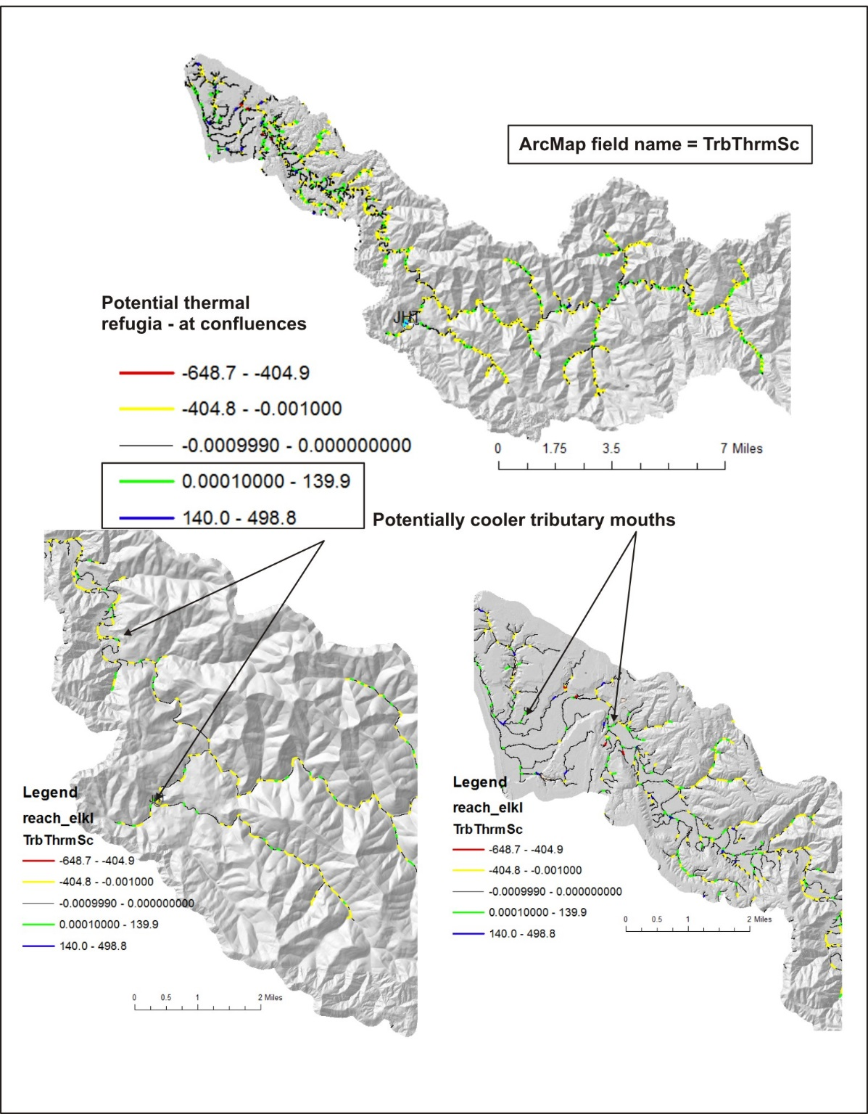
Figure 24. Potential confluence scale cooler water conditions are predicted across the watershed.

4.4 Erosion (Slope Stability) Analysis
NetMap’s slope stability analysis is applied to the Elk River watershed to identify hillslope areas prone to shallow failure and to predict headwater channels susceptible to debris flows. Shallow landsliding is driven by hillslope (or swale) gradient, degree of topographic convergence, and contributing drainage area (Montgomery and Dietrich 1994, Miller and Burnett 2007). To analyze these processes NetMap’s ‘Generic Erosion Potential’ (GEP) attribute is applied. GEP provides a relative measure of potential erosion based on slope steepness and convergence, recognized topographic indicators of shallow landsliding and gully erosion. GEP is based on topographic attributes of slope gradient, local contributing area, and topographic convergence derived from the DEM:

GEP = S*aL/b

where S is slope gradient (m/m), aL is a measure of local contributing area to a DEM pixel equal to the number of adjacent pixels that drain into it (varies between 0 and 8), and b is a measure of topographic convergence equal to the projection of flow direction out of a pixel onto the pixel edges. Values of b are 1 on planar slopes, less than 1 on convergent topography, and greater than 1 on divergent topography. Higher values of GEP are calculated in areas of steeper, more convergent topography. Higher values of GEP correspond to higher landslide densities and to higher gully-initiation-point densities (Miller and Burnett 2007).

For increased accuracy, GEP is calibrated using occurrences of landslides mapped from aerial photography (Figure 25). Seventeen landslides were inventoried on the 1997 aerial photographs. Values of hillslope gradient and landform curvature are extracted from NetMap’s virtual watershed and they are used to calibrate GEP in terms of landslide density (# of slides per km²). Predicted values ranged from a low of zero to 4.9 slides km⁻² (Figure 26). Areas mapped as high potential on planar slopes generally have gradients of greater than 90% (as estimated from the DEM). Areas mapped as high potential on convergent slopes generally have gradients of greater than 70%.
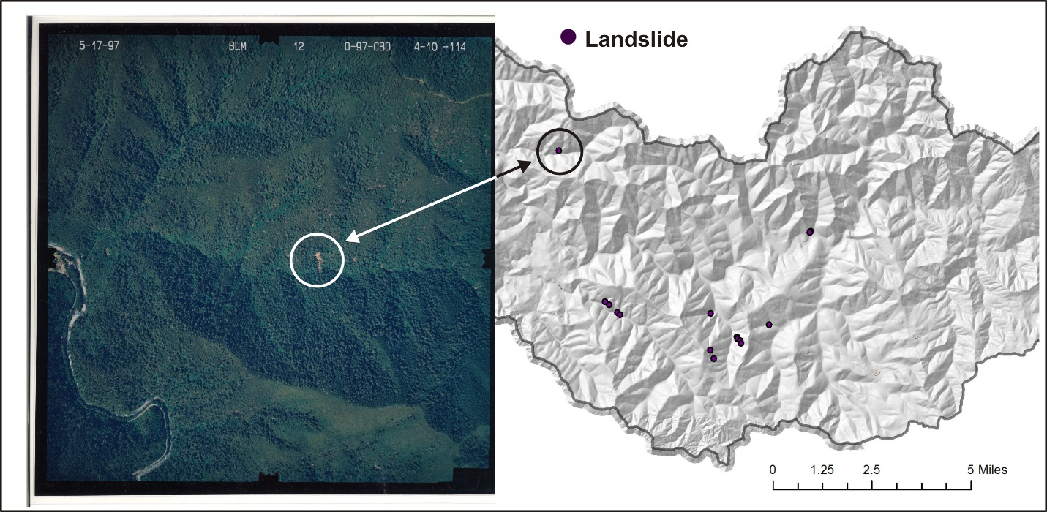
Figure 25. Landslide inventory in the Elk River basin.
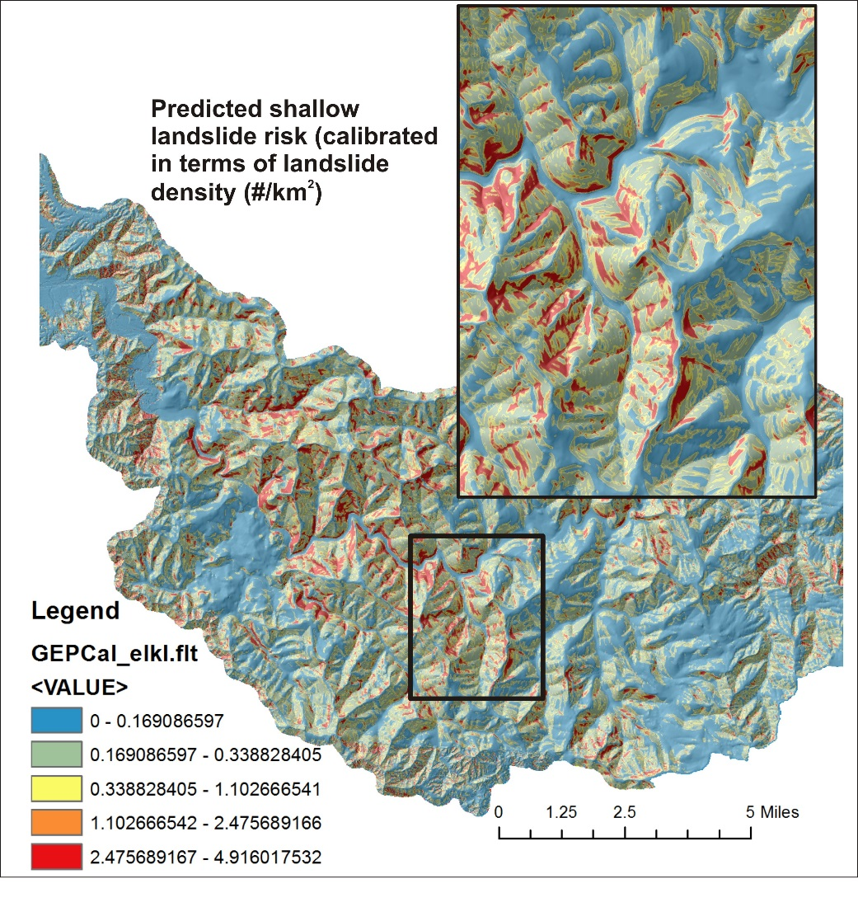
Figure 26. Calibrated shallow landslide model predictions.
The susceptibility of headwater channels to debris flow scour and deposition (based on Miller and Burnett 2008) was predicted in the Elk River basin (Figure 27). Overall, basin-wide, the Elk River basin has low to moderate susceptibility to debris flows compared to other watersheds in the central coast range. Nevertheless, there are groups of headwater channels that are prone to debris flows, and maps can be overlaid onto Google Earth to enhance visualization of this potential hazard (Figure 28).

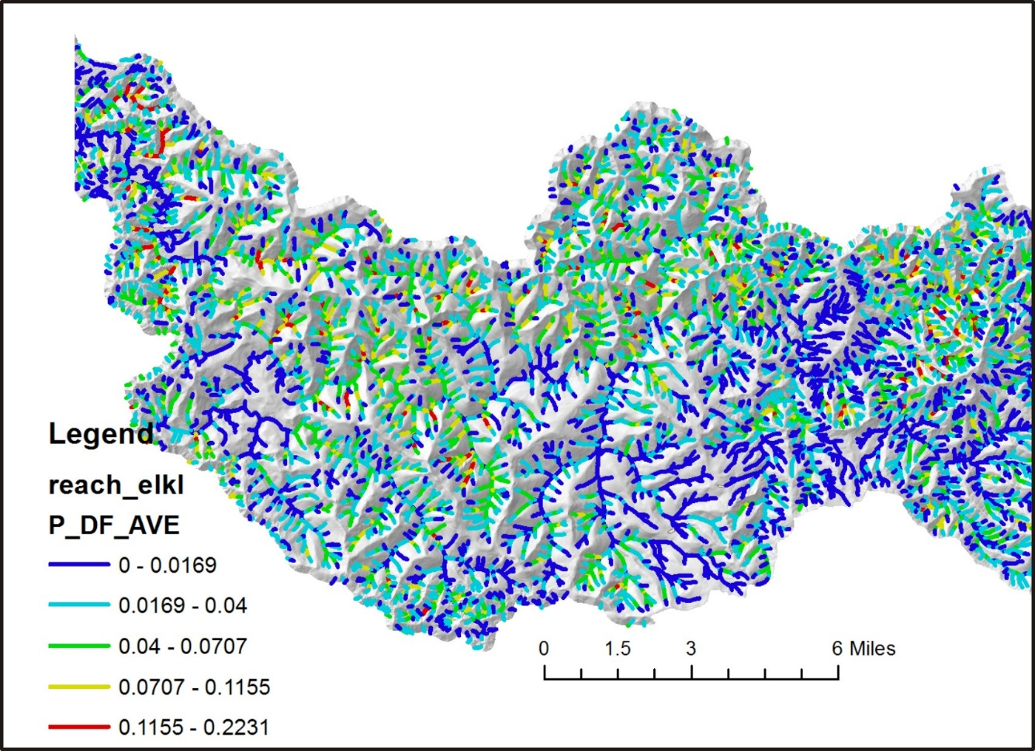
Figure 27. Predicted debris flow potential in the Elk River watershed.

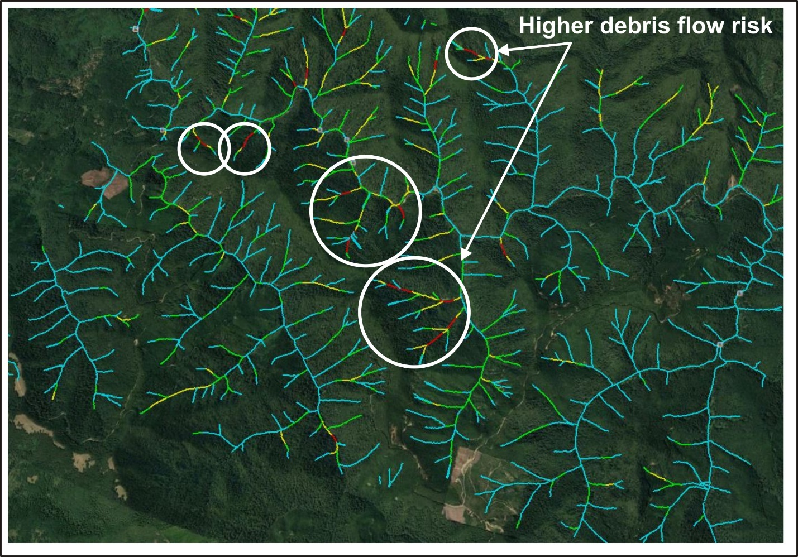
Figure 28. NetMap’s predicted debris flow susceptibility in headwater channels overlaid onto Google Earth.

4.5 Forest Road Analysis
A model of unpaved road erosion and sediment delivery to streams (READI) is used to assess effectiveness of existing road engineering and maintenance at reducing sediment delivery to streams and to optimize future reductions in the Elk River watershed. Sediment production is driven by road surface area and slope and can be modified by rainfall intensity, surfacing and traffic; in the absence of reliable data on erosion rates, sediment production is dimensionless (as applied here). Road runoff hydrographs at drains and streams are generated using storm intensities and durations that deliver flow, with sediment, directly to streams at road-stream intersections or into the forest floor where runoff is either attenuated by soil infiltration or delivered to streams.
Vector road layers are draped onto the DEM and disaggregated at pixel borders. Road vector pixels are re-aggregated per topographic high and low points to determine road segments that drain directly to streams or to the forest floor. Road segments were further divided into smaller segments using geo-referenced locations of engineered drainage structures on the National Forest (data supplied by the US Forest Service) (Figure 29). Junctions between two or more roads are treated as a drain point. A synthetic river network in NetMap, derived directly from surface flow routing and accumulation using DEMs, is used to identify all road-stream intersections. Each discreet road segment not directly connected to streams is hydrologically connected to individual channel segments via modeled overland flow paths within the virtual watershed, allowing precise connectivity between roads and streams for analysis of sediment delivery.
READI in the Elk River watershed was run as a dimensionless index (Erosivity parameter set to one). All roads are assumed to have the same surfacing (because of the large number of road segments in the road shapefile that had unknown surfacing). If forest roads are a mixture of gravel, native and paved, READI can be rerun but individual road segment surfacing will need to be identified. Ditches are assumed to occur along all segments (1 m wide). Soil infiltration rate was set to 0.12 m hr⁻¹ and the one-hour duration design storm had an intensity of 0.02 m hr⁻¹. The forest floor runoff plume width was set to 1.5 m. The outslope proportion was set to 0.25 (25% of the road width outsloped); road width was set to 5 m. The objective of the analysis is to provide a relative ranking of road segments that are most likely to deliver sediment to streams either at road – stream crossings or via the forest floor. READI has been submitted for publication and additional information on the model can be found here.
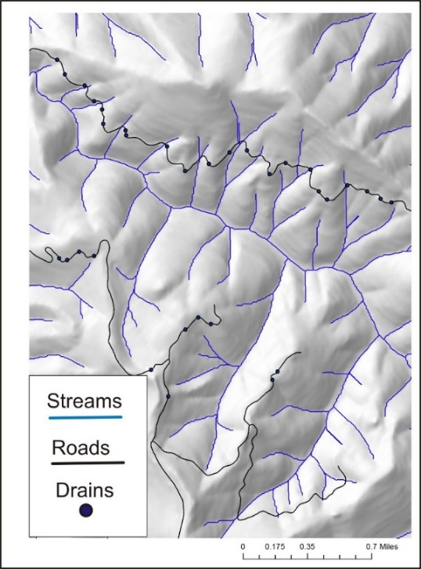
Figure 29. Road drain data used in the READI model.
READI predicts that all forest roads produce sediment but a smaller proportion of total sediment production is to delivery sediment to streams (21%) (Figure 30). Twenty-two percent of the total road length is predicted to be hydrologically connected to streams. The mean predicted runoff sediment plume length is 17 m.
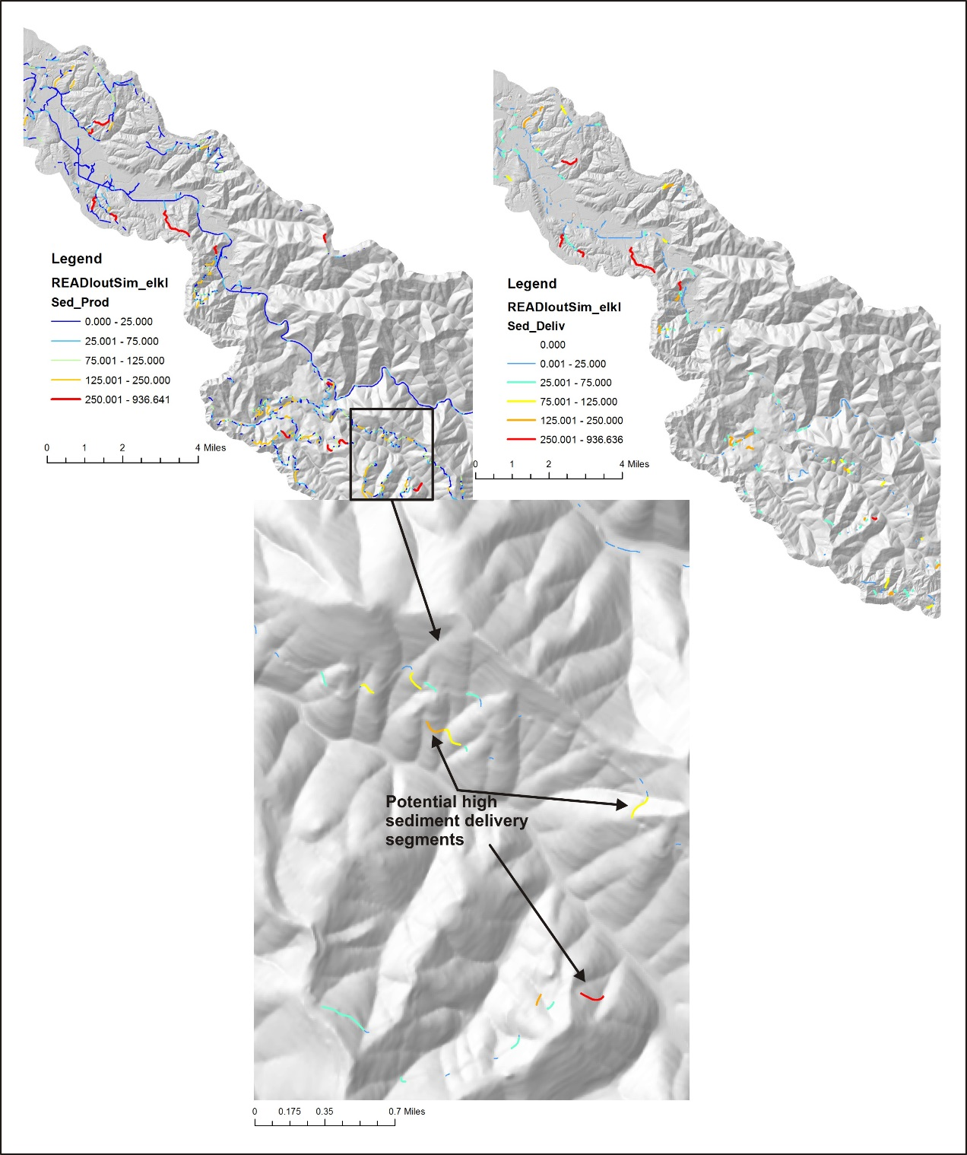
Figure 30. Predicted road sediment production and delivery. This type of road map could be used to prioritize future road maintenance and remediation efforts, including upgrading surfacing.

READI includes the ability to identify locations where additional engineered drains will be most effective at reducing delivery of water and sediment to the stream system. To locate optimal drain locations across a road network, READI analyzes each road drain in the network individually, starting with the drain with the largest sediment delivery, and searches for locations along the associated road segment(s) where a new drain would minimize sediment or water delivery. The model assesses each road segment, meter-by-meter, placing a new drain and calculating the combined delivery from the new and original drains to find the lowest minimum along the segment. A minimum drain spacing can be specified to reflect engineering or vehicle constraints to drain placement.
This procedure is done for all drain points as the model moves through a priority queue, examining all drains in order from highest to lowest delivery. This ensures that the optimal location is always at the top of the queue, even if it happens to fall within one of the newly created segments. This procedure is repeated until the specified number of new drains are added. Any number can be specified, from one to a maximum where the cumulative reduction of runoff and sediment delivery across all road segments attains a minimum, that is, until continued addition of new drains no longer reduces the total amount of water or sediment delivered to streams. READI provides a list of new drain points, each with an associated reduction in total delivery of water or sediment, ranked in order from the largest reduction to the least.
We applied the maximized the number of drains in the Elk River analysis (Figure 31). Predicted (dimensionless) sediment delivery was reduced from a total of 27,134 to 3,912, a reduction of 86%. Following placement of all drains (3,455, thus probably unrealistic) only 3% of total sediment production was delivered to streams and only 3% of the road is hydrologically connected to streams. However, the optimized drains are ranked in terms of effectiveness (amount of sediment reduced) and these can be used to prioritize drain placement for the most effectiveness (Figure 32). READI also contains the ability to predict where upgrading road surfacing (native to gravel or paved) would be the most effective in reducing sediment delivery (not included here because of uncertainty in existing road surfacing).
Sediment from roads (pre-optimized) is routed to streams and accumulated downstream and normalized by drainage area (Figure 33). Such information could be overlaid onto sensitive fish habitats to further prioritize where additional sediment delivery abatement measures might be applied.
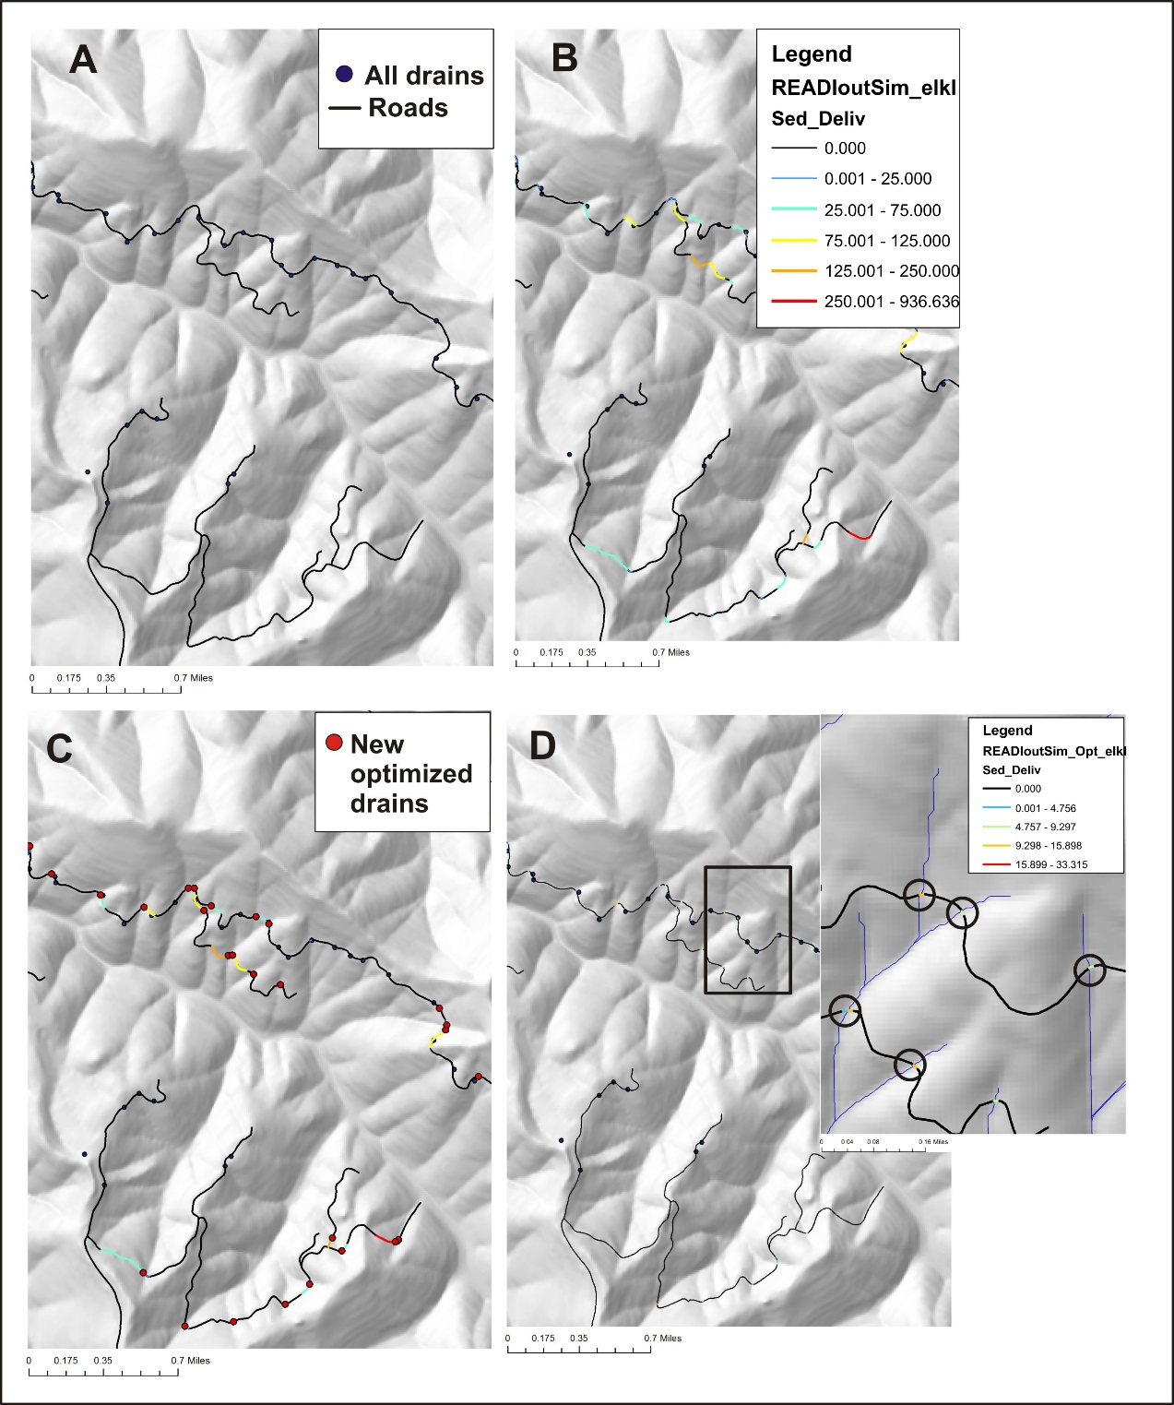
Figure 31. (A) Existing road drains, includes road-stream crossings, natural topographic low points and road segment junctions. (B) Predicted sediment delivery to streams. (C) Location of optimized drains also showing predicted sediment delivery prior to those drains. (D) Predicted sediment delivery following optimized drains. Inset in (D) shows the remaining short road segments that continue to supply sediment to streams.

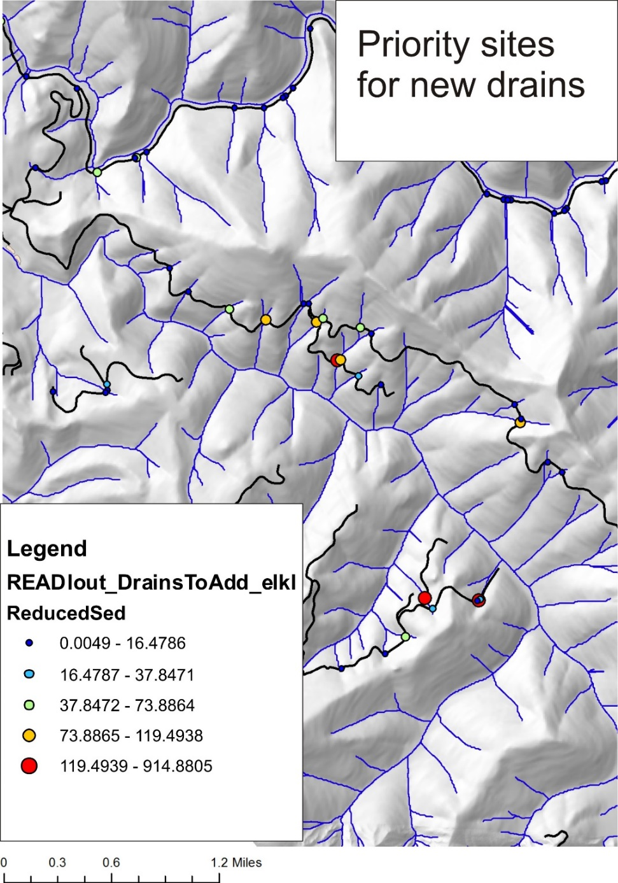
Figure 32. Optimized drains can be mapped according to their relative effectiveness at reducing sediment.

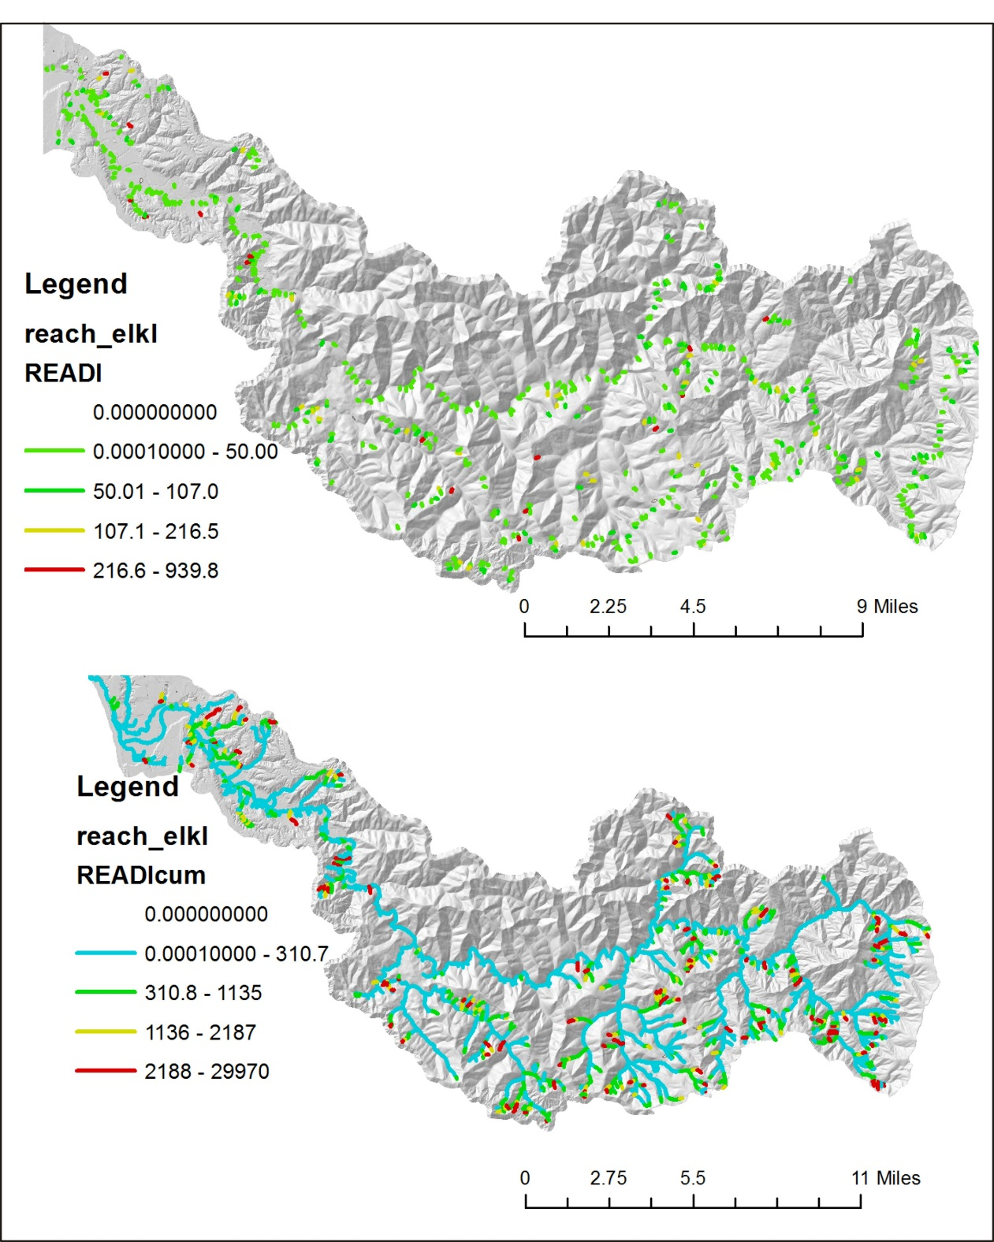
Figure 33. (Upper) Predicted forest road sediment is routed to individual stream segments. (Lower) Sediment delivery is then aggregated downstream and normalized by drainage area, providing a tributary scale perspective of sediment delivery.

NetMap’s other road tools include road stability that can be used to help prioritize where additional remediation efforts can be applied to lessen the risk of road failures and the triggering of shallow landslides and debris flows (Figure 34). To learn more, see NetMap’s Tech Help.
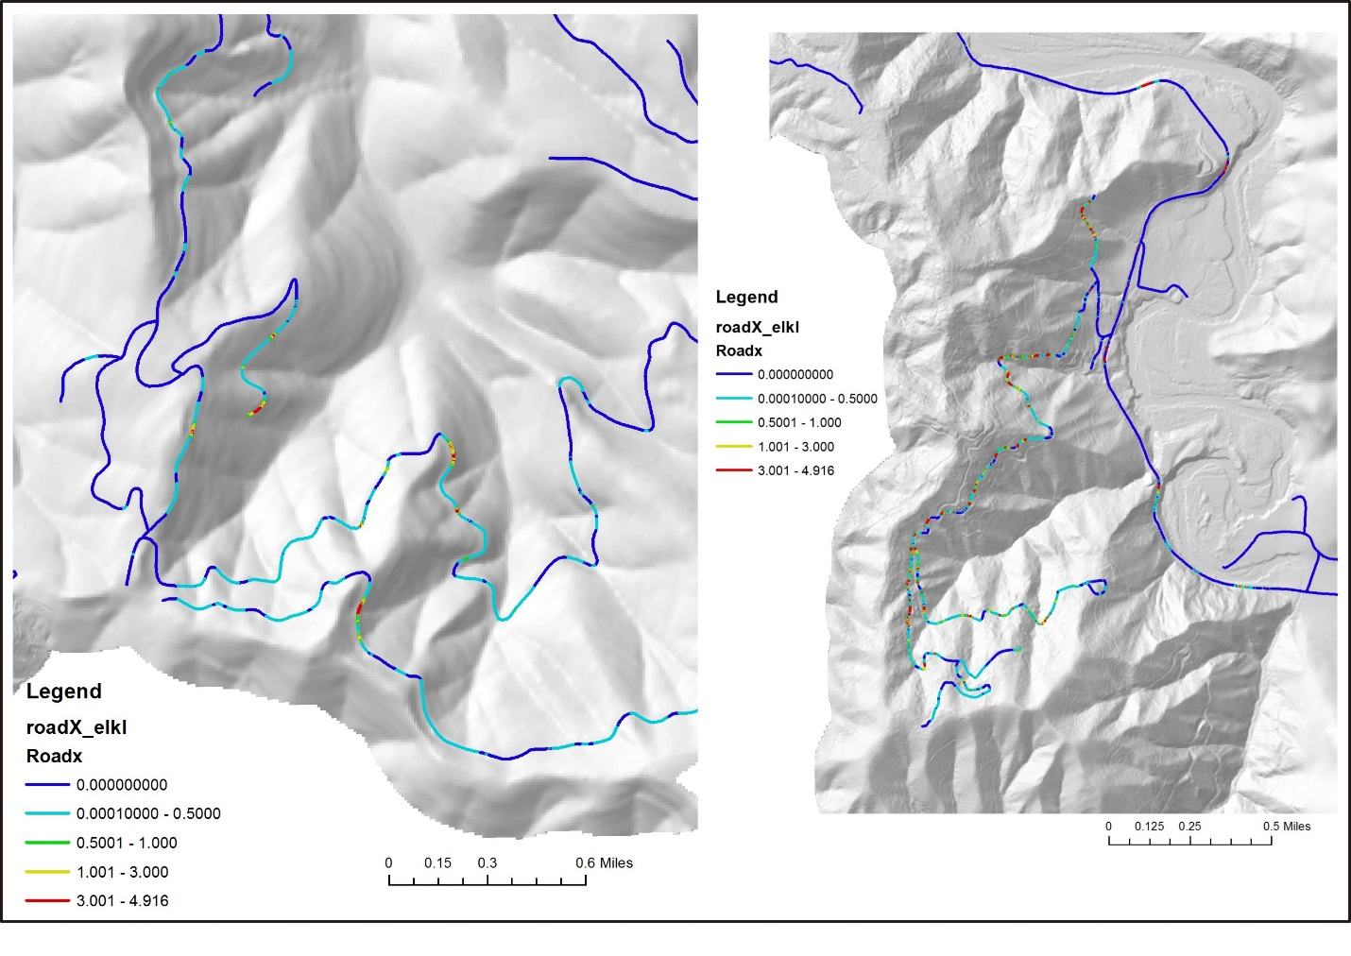
Figure 34. Predicted potential road stability, based on the calibrated shallow landslide model in Figure 26.

NetMap’s debris flow predictions in headwater channels can be overlaid with the road layer to identify road crossings that might be at risk from debris flow damage, or from road failures that trigger debris flows (Figure 35).

Another road analysis is the cumulative length of predicted fish habitat upstream of all road crossings. This was done for coho habitat (Figure 36).
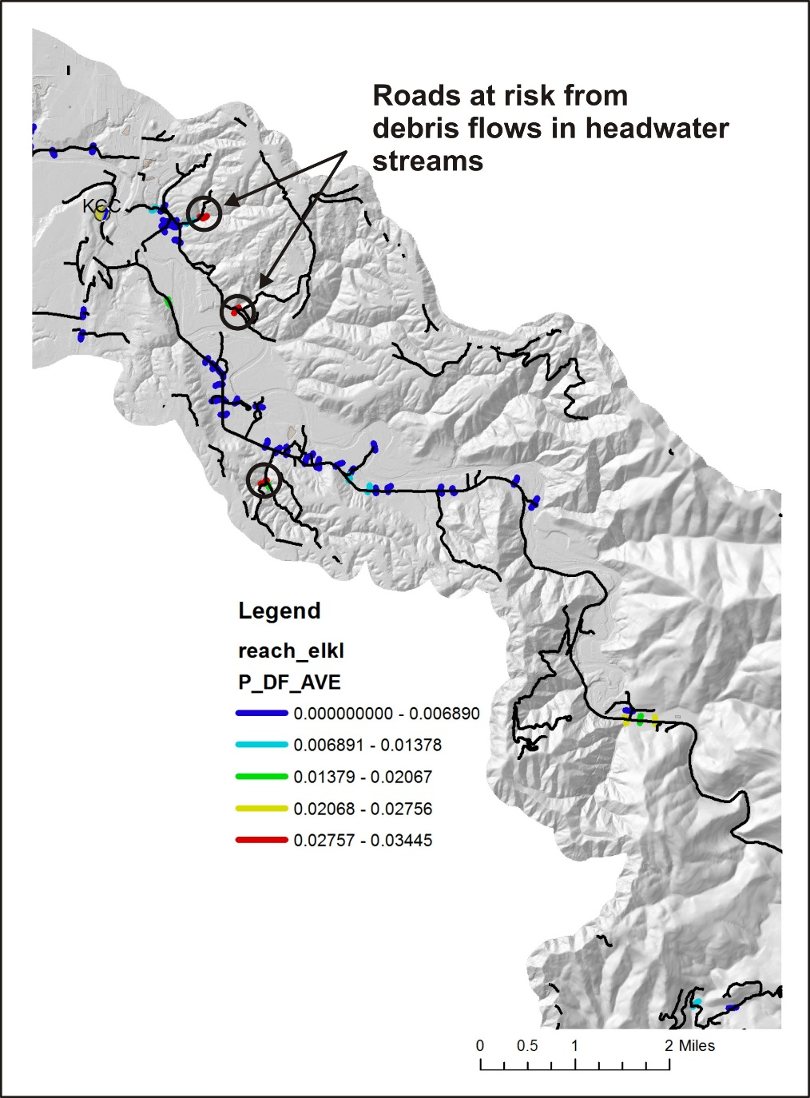
Figure 35. Predicted forest road – debris flow risk in headwater channels.

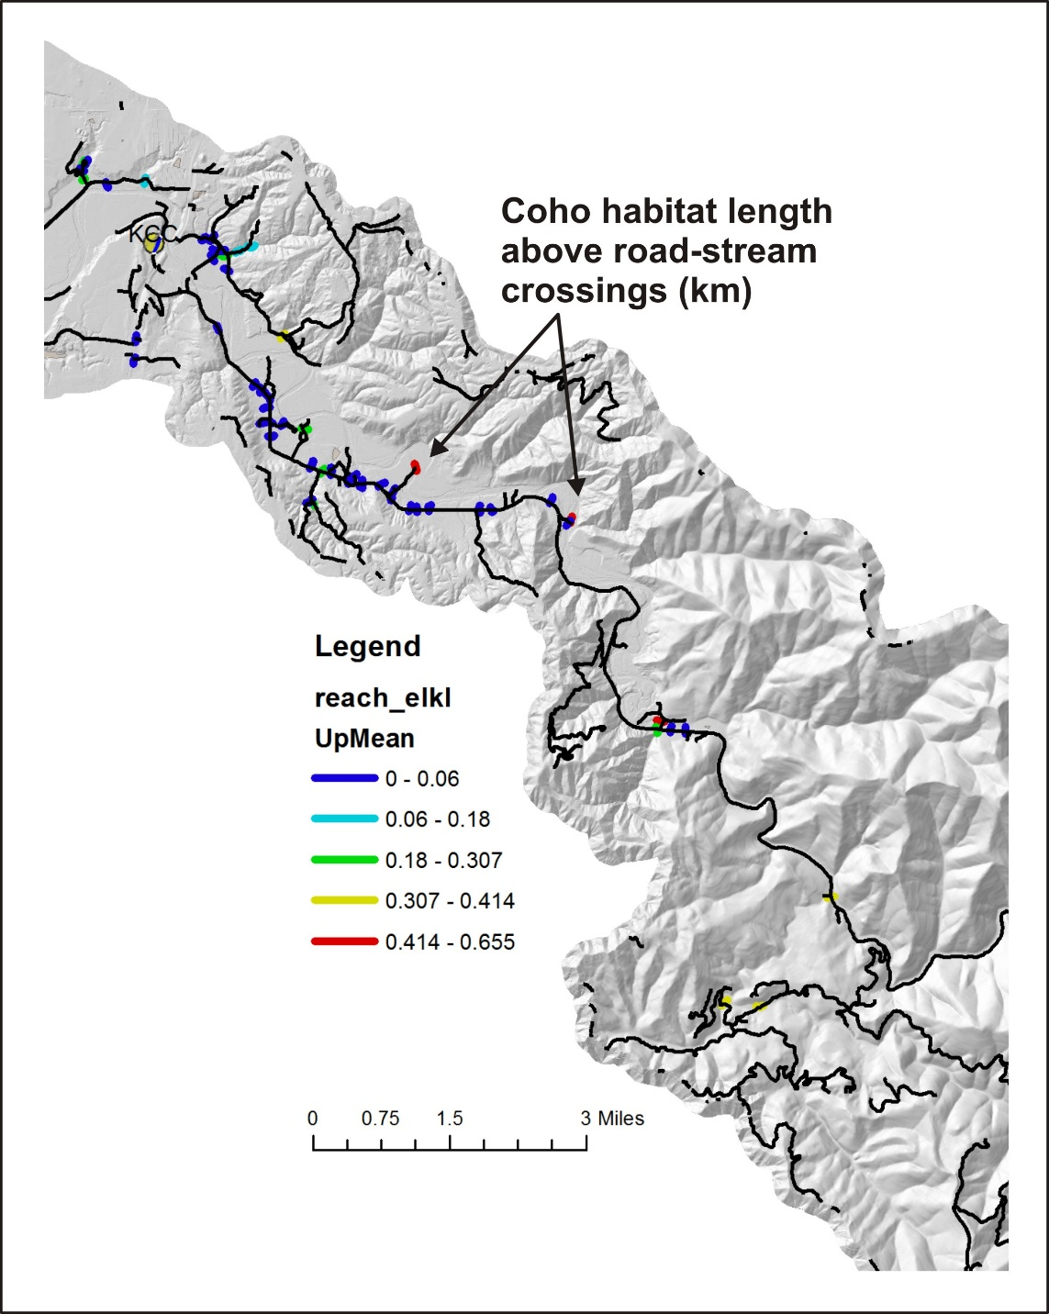
Figure 36. Cumulative coho habitat length (km) upstream of every road-stream crossing.

4.6 Upslope Sources of Large Wood
Landslides and debris flows can be large sources of wood to streams in the Oregon Coast Range. NetMap can be used to map the major sources of large wood to streams from shallow landslides and along debris flow scour paths. The predictions are based, in part, on the slope stability analysis described above (Section 4.4). Additional information on predicting upslope sources of large wood can be obtained at NetMap’s online technical help.
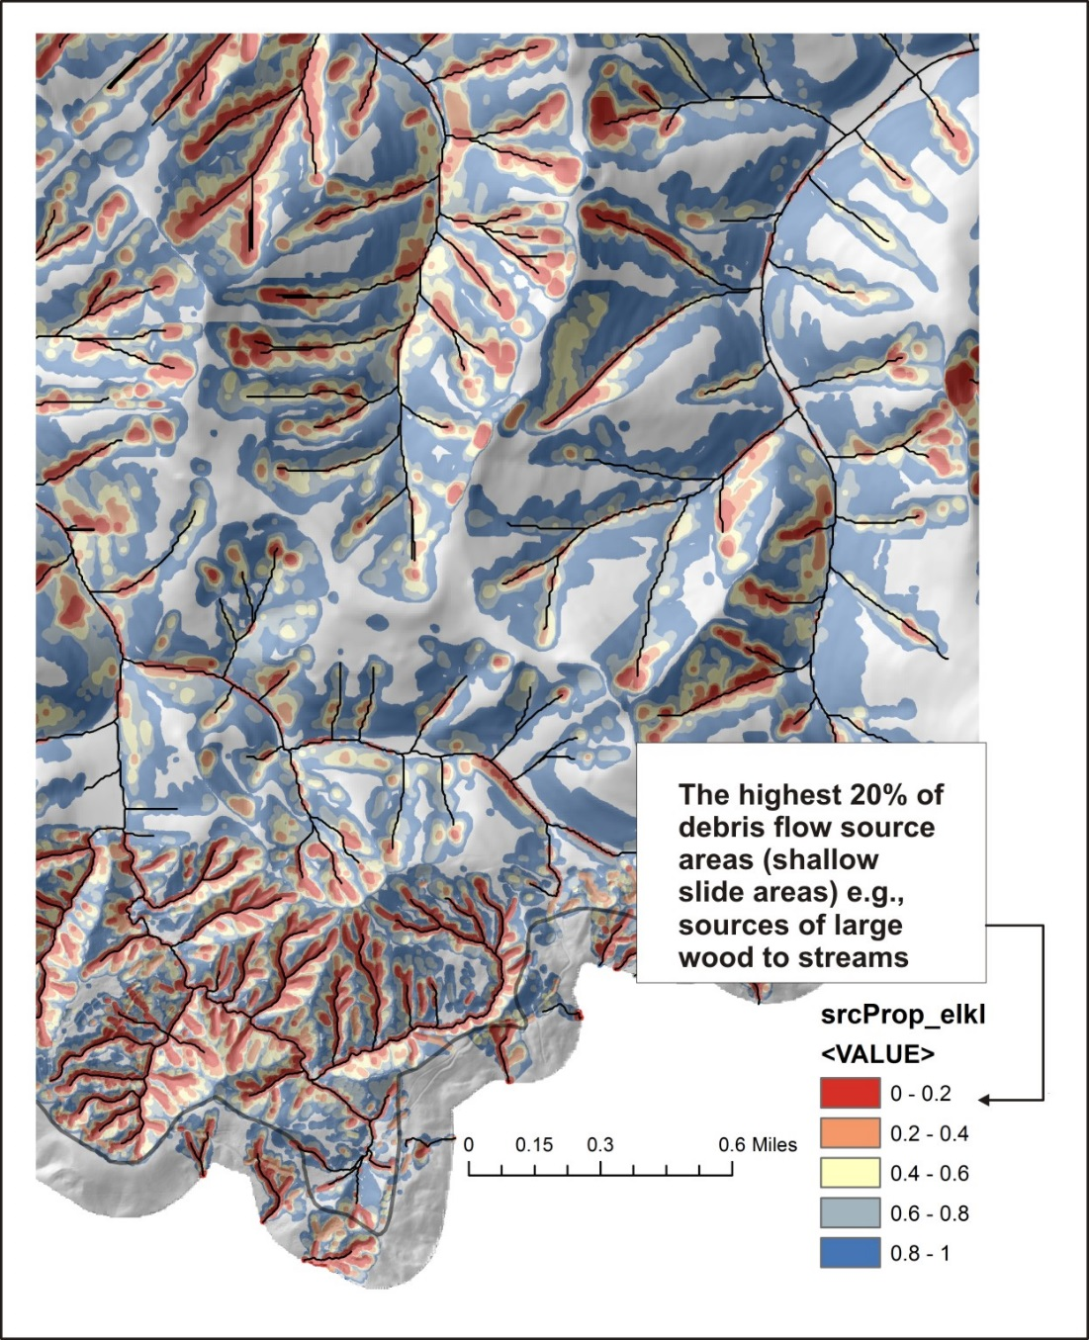
Figure 37. The NetMap attribute SrcProp that can be used to identify upslope areas that can contribute large wood to streams. Defined as the proportion of area that encompasses landslide initiation points (GEP based shallow landslide grid cells), 0 – 0.2 = the highest 20% of landslide initiation points starting with the most unstable, 20-40%, the next quartile etc. all four quartiles = 100% of all the landslide risk.
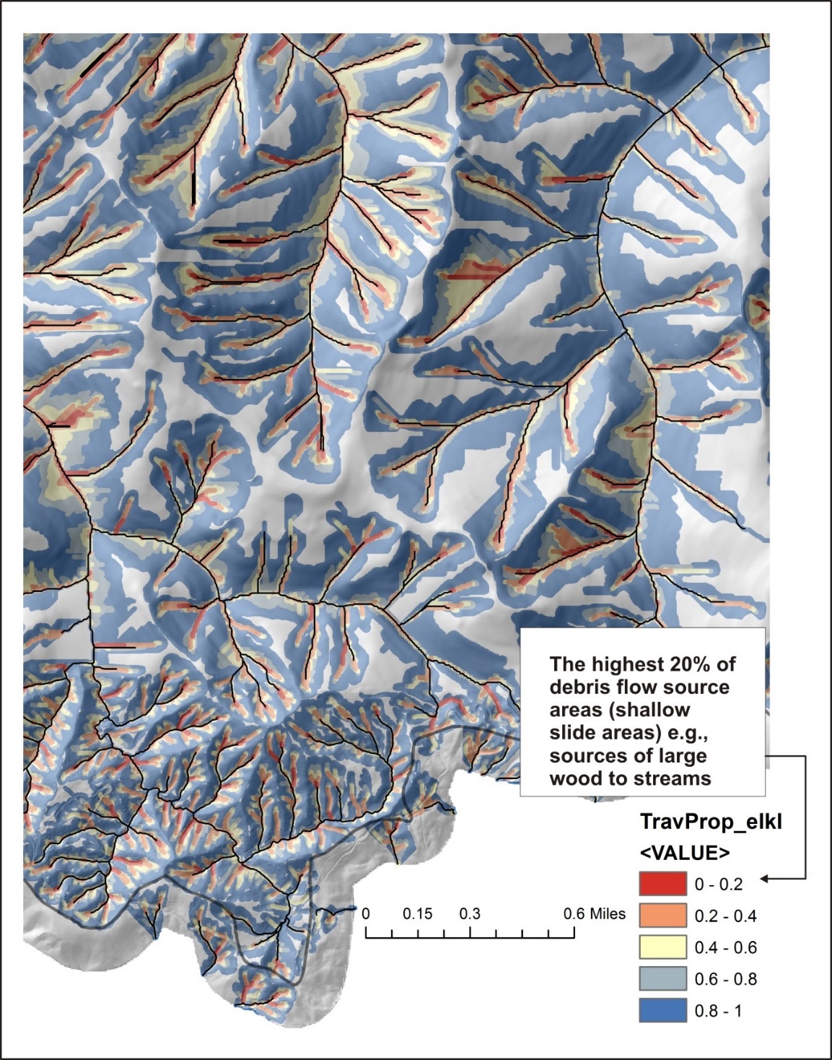
Figure 38. Trav_Prop, a NetMap attribute that can be used to identify upslope zones of large wood recruitment, in terms of cumulative probability of debris flow traversal in individual cells, and it is based on a gradient threshold for that traversal; default value is >=0.04. For example, the amount of traversal with a delivery of 0.2 will be higher than with a delivery of 0.02.

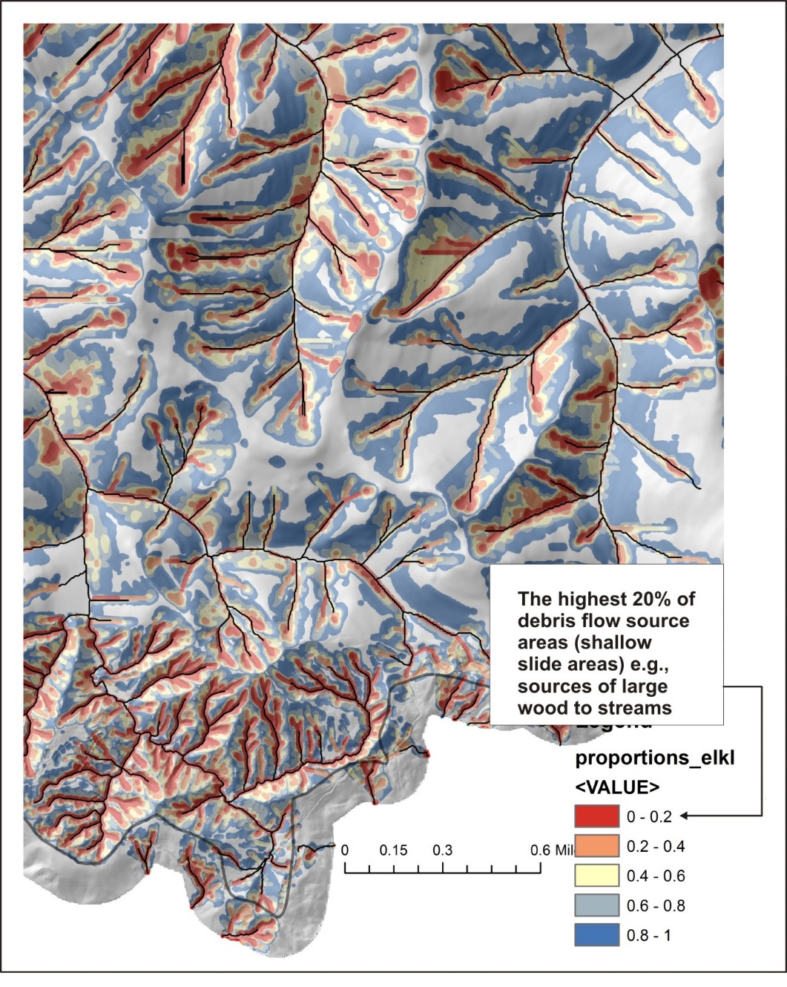
Figure 39. Proportions, a NetMap attribute that can be used to identify upslope zones of large wood recruitment, in terms of cumulative probability of 1) shallow landslide potential and debris flow runout in individual cells, and it is based on a gradient threshold for that traversal; default value is >=0.04. For example, the amount of traversal with a delivery of 0.2 will be higher than with a delivery of 0.02. This attribute combines Figures 37 and 38.

5.0 Setting Restoration Priorities

5.1 Linking NetMap Outputs to Current Restoration Planning Objectives and Site Selection
The Elk River – NetMap Restoration Watershed Analysis results can be used to help inform the existing set of restoration priorities (Elk Coho score sheet, Sept 1.xlsx). This is illustrated using three sites.
1) Indian Creek: Wetlands/off-channel: Reconstruct lower 1/8 mile of channel to restore floodplain/wetlands habitats Good source of cold water. Note: Sediment is a major concern from tributaries from Indian Creek and below. NetMap’s analysis supports the selection of this site for restoration, particularly in terms of coho habitat potential, thermal refugia, current shade and added shade effectiveness and current in-stream wood (Figure 40).
2) Swamp Creek: Wetlands/off-channel: Downstream of reservoirs: reconstruct channel to increase sinuosity and connect to floodplain. Add LWD. Remove gorse and improve riparian. This site selection is also consistent with NetMap predictions (Figure 41).
3) Bald Mountain Creek: Lower half-mile is high priority for riparian restoration (DEQ 2003). The lower two miles are 303d listed due to stream temp and habitat modification. The creek has high flows and a narrow floodplain. Hard to get LWD to stay. Sediment abatement from roads is a high priority in Bald Mountain Creek watershed. #2 road storm-proofing priority on WRLT list. Although this site has some potential for restoration, it would be ranked on the lower end at the entire watershed scale (Figure 42).

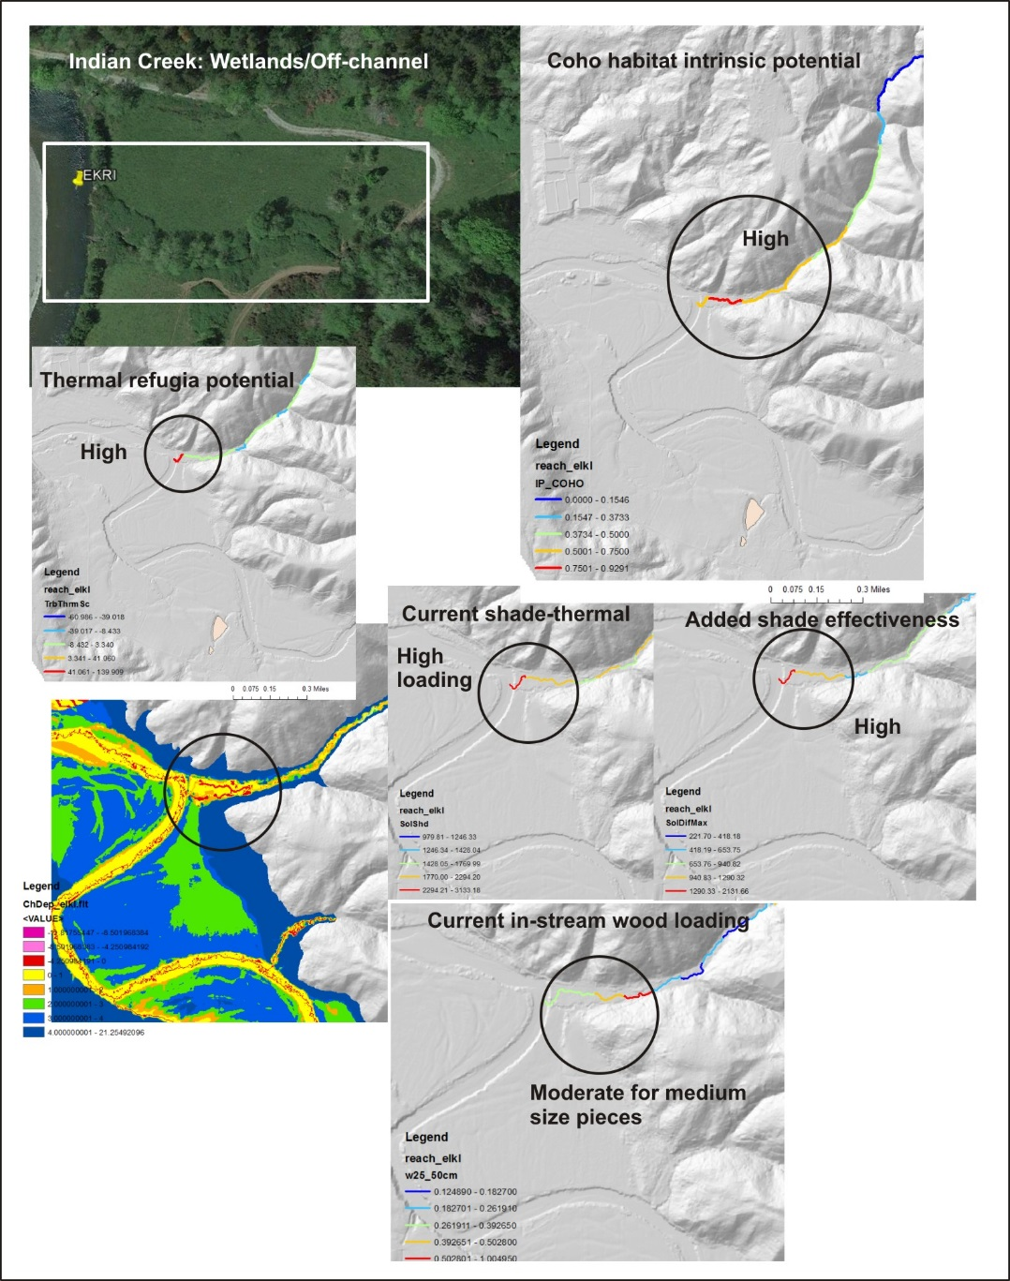
Figure 40. Indian Creek proposed restoration site.

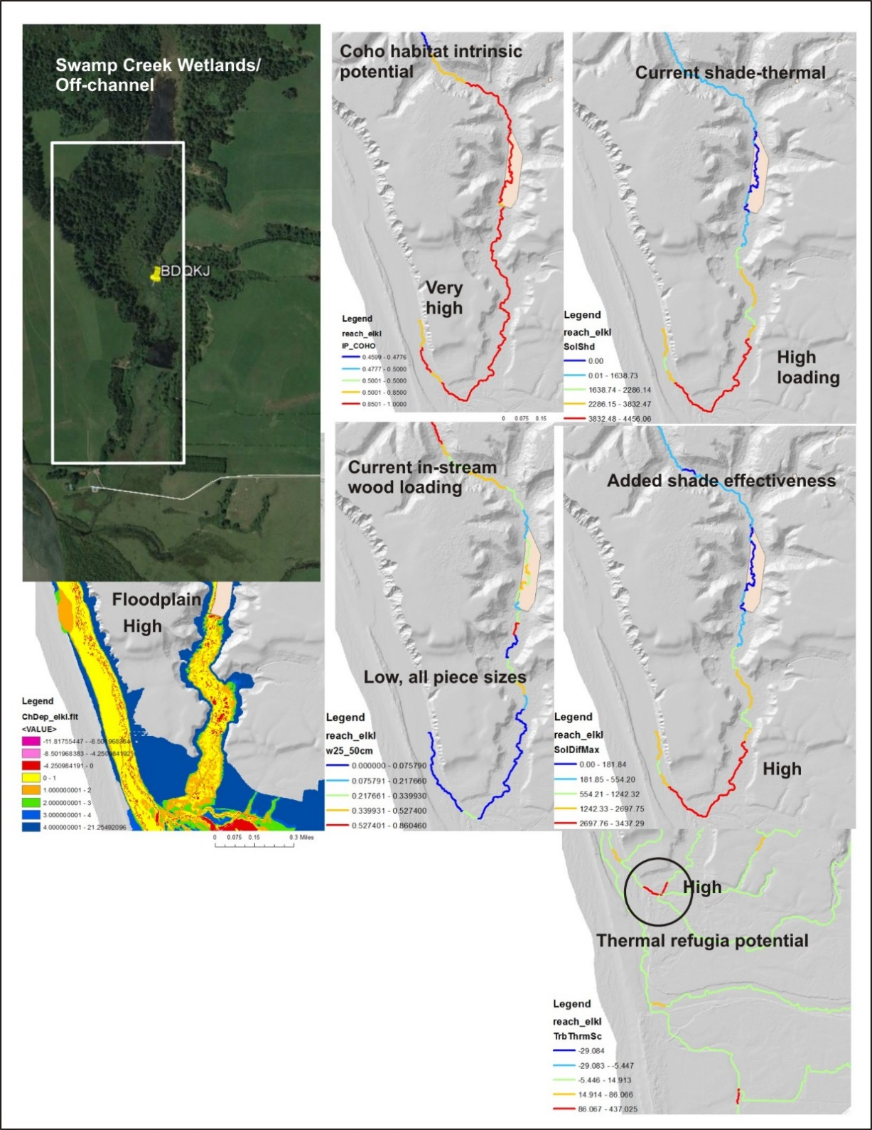
Figure 41. Swamp Creek proposed restoration site.

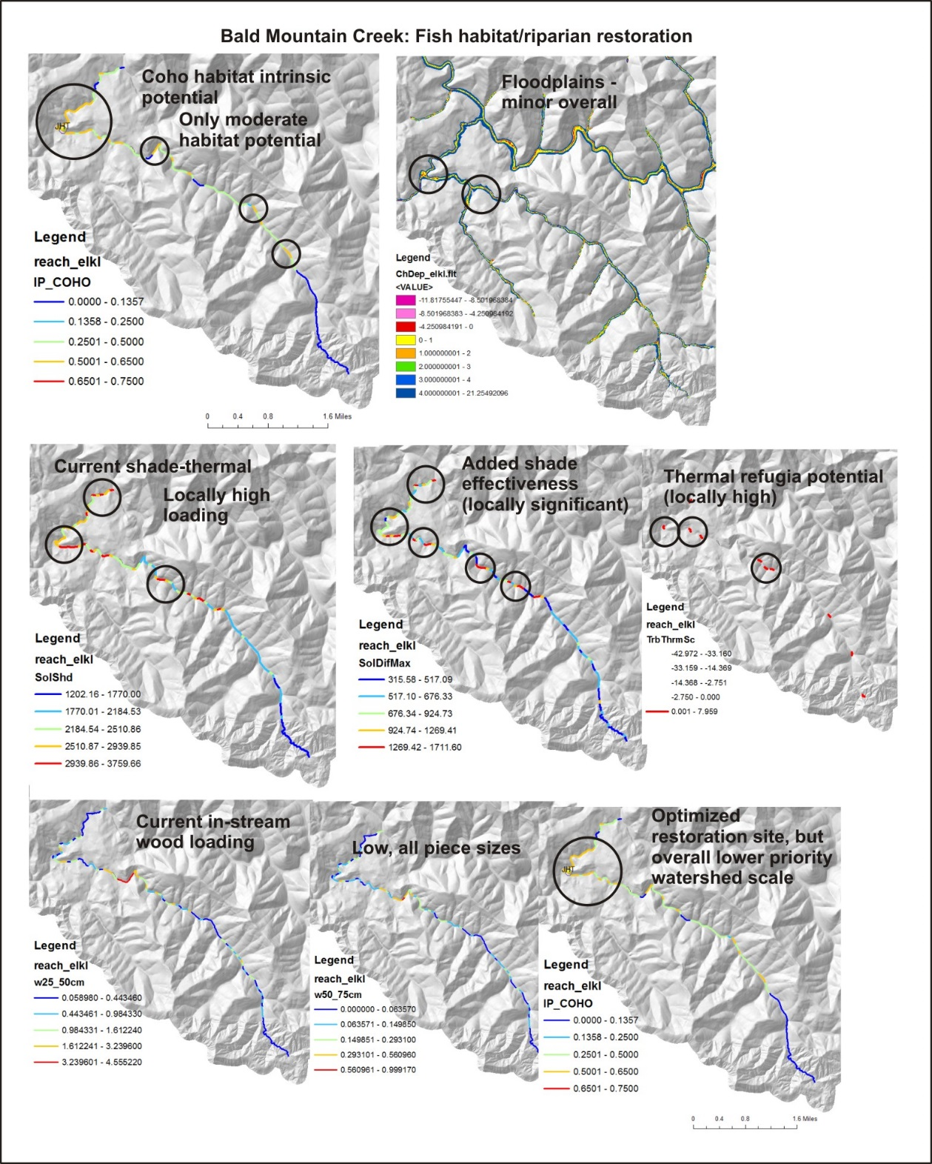
Figure 42. Bald Mountain proposed restoration site.

5.2 Where are the Best Coho Salmon Habitats?
The highest 10% of coho intrinsic potential values are identified in Figure 43. One hundred and ninety stream segments out of a total of 2009 were identified as having IP scores greater than 0.64 or 9.5% of all segments. This is equivalent to 18.3 km out of a total of 199 km or about 9% of the coho stream length. Intrinsic potential scores > 0.75 are often considered the best potential habitat quality; there are 161 channel segments, or 15.4 km, of coho habitat greater than 0.75 and 90% of it is located in the lower river basin (Figure 44).

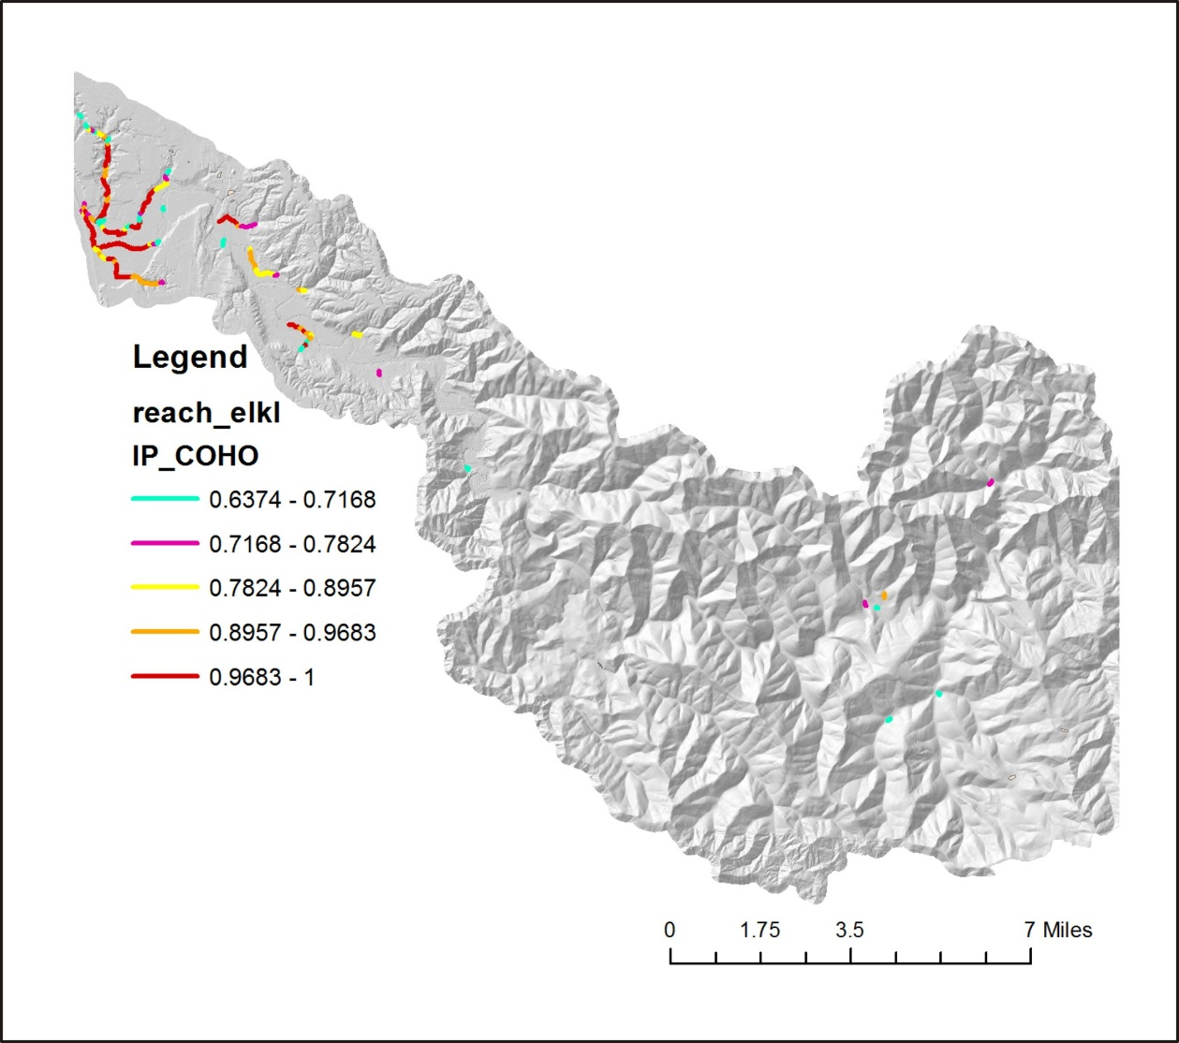
Figure 43. The highest 10% of coho IP scores in the Elk River watershed.
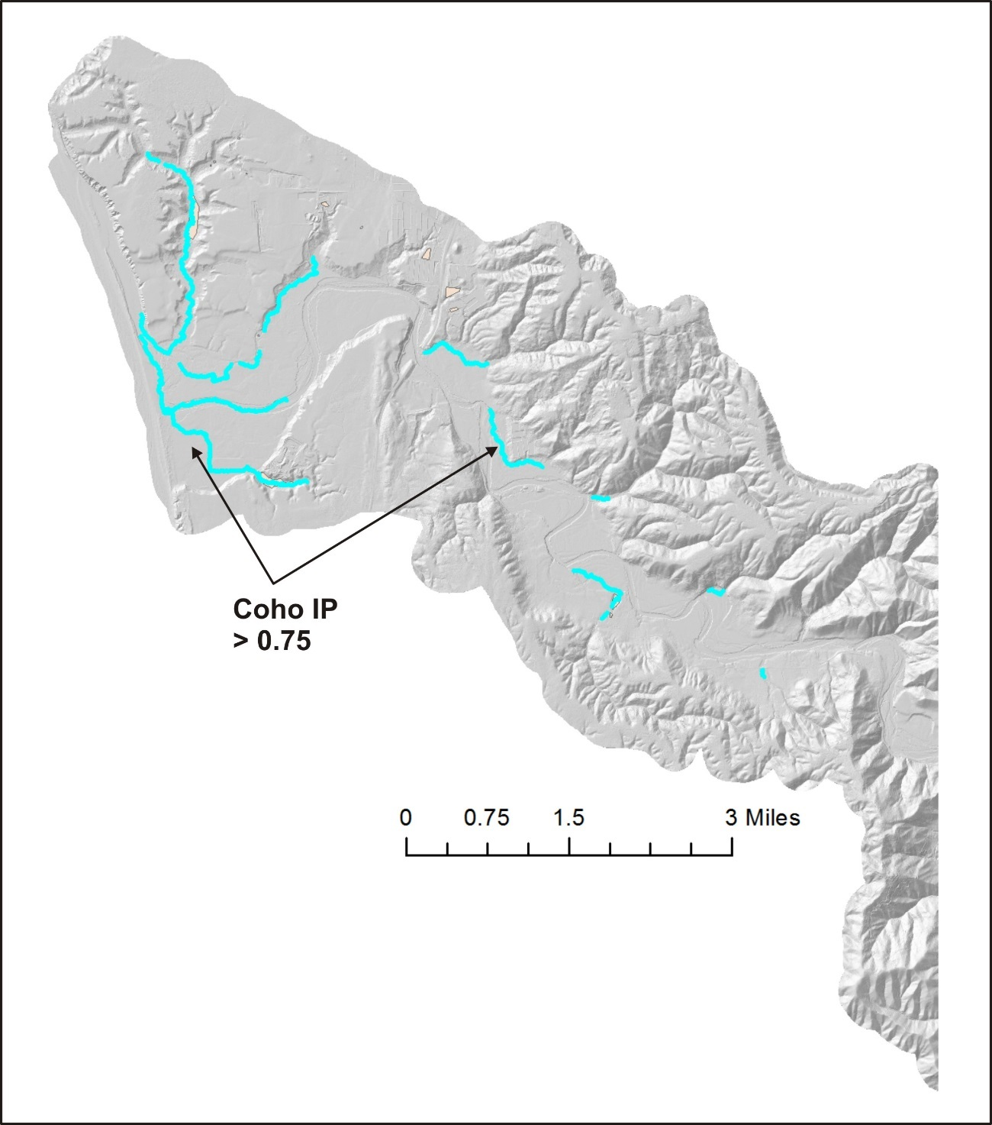
Figure 44. Coho IP scores > 0.75.

5.3 Where Additional Stream Shade is Needed Most?
To identify stream segments where additional shade would be most effective at reducing thermal loading to streams, the highest 10% effectiveness is mapped in Figure 45. One hundred and ninety-nine segments out of 2009 segments or a length of 19.7 km out of a total of 199 km of streams was identified.
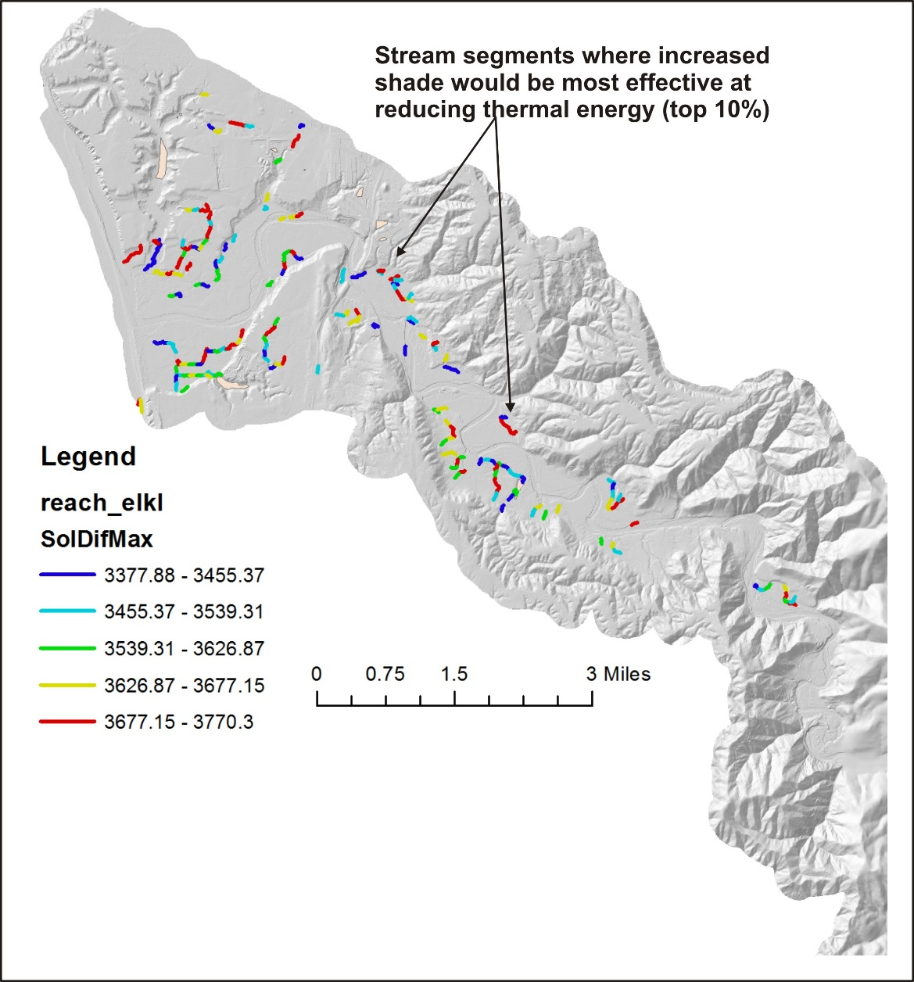
Figure 45. The highest 10% of reaches where additional shade would be most effective at reducing thermal loading.

5.4 Where In-Stream Wood is Needed Most?
The highest coho intrinsic potential could be overlaid onto those reaches with the lowest wood recruitment potential (average of all wood diameter classes). To illustrate this using NetMap, the highest 5% of coho IP scores were overlaid onto the lowest 60% of in-stream wood recruitment potential using NetMap’s reach overlap tool. Eight five reaches out of a total of 2009 reaches or 8.4 km out of 199 km, about 4% of the total channel length, were identified to have this combination of attributes (Figure 46). All the selected reaches are located in the lower watershed.
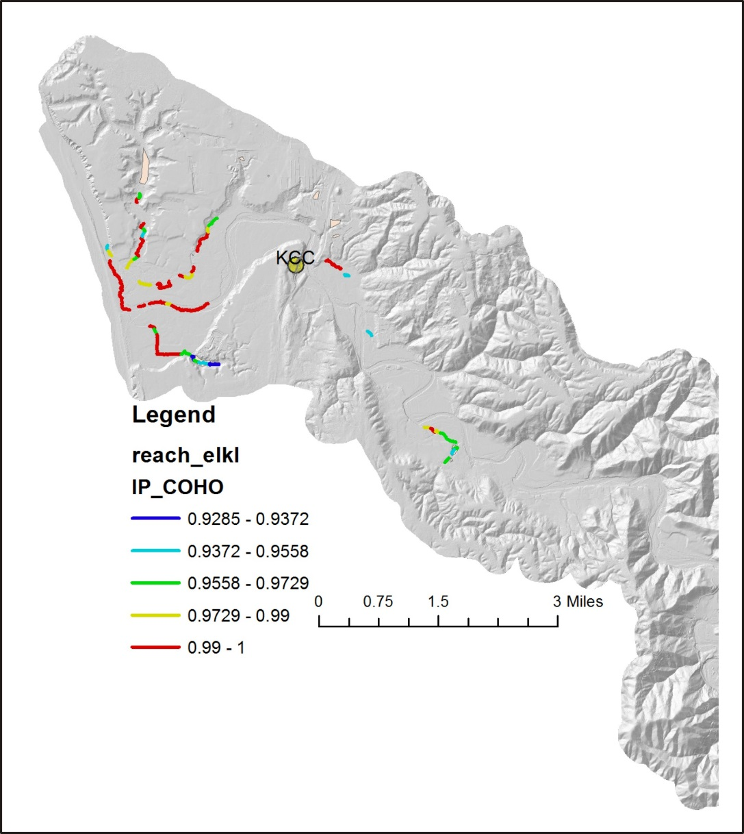
Figure 46. Locations where the highest 5% of coho IP scores overlap with the lowest 60% of in-stream wood recruitment potential.

5.5 Where Valley Floor-Floodplain Ecological Hotspots Could be Enhanced?
NetMap attributes of floodplains and valley floor elevations, coho IP, current shade/thermal loading (most effective sites for additional shade), current in-stream wood loading, and two cool water refugia types, were used to identify a provisional set of the best coho-floodplain sites for restoration (Figure 47).
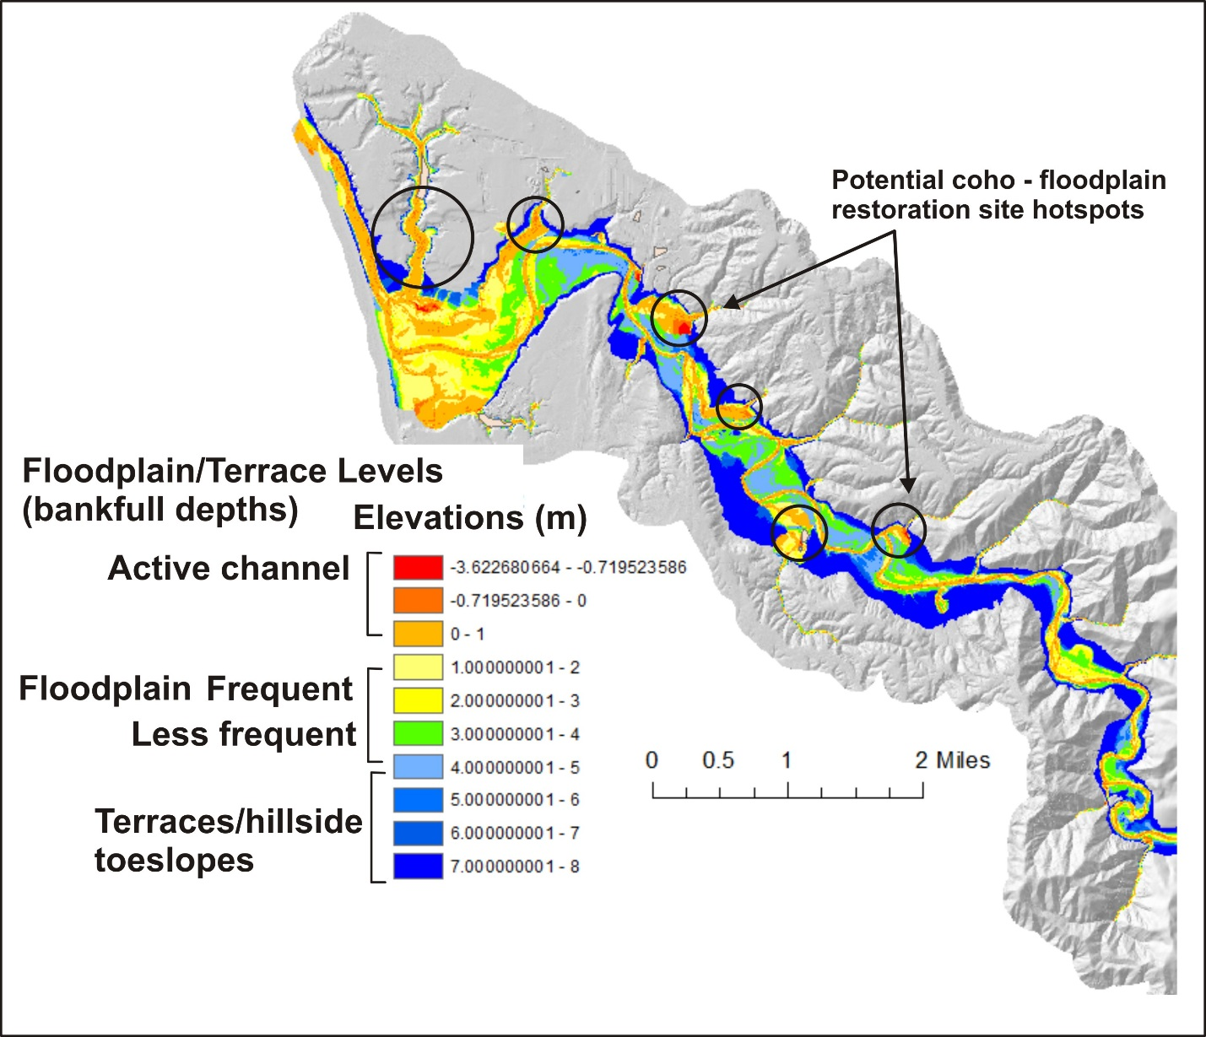
Figure 47. Provisional coho-floodplain restoration hotspots predicted using the NetMap restoration watershed assessment.

5.6 At What Locations Would Road Surface Upgrades Reduce Sediment Delivery?
See Figure 30.

5.7 At What Locations Would New Drainage Features Optimize Reductions in Road-Stream Connectivity and Sediment Delivery to Streams?
See Figures 31 and 32.

References
Bannister, N., J. Mant, and M, Janes. 2005. A review of catchment scale river restoration projects in the UK. Report by the River Restoration Center; Sponsored by the Environmental Agency. 48pp.

Benda, L., Sias, J., 2003. A quantitative framework for evaluating the wood budget. J. For. Ecol. Manage. 172, 1–16.

Benda, L., D. J. Miller, K. Andras, P. Bigelow, G. Reeves, and D. Michael. 2007. NetMap: A new tool in support of watershed science and resource management. Forest Science 52:206-219.

Benda, L., D. Miller, S. Lanigan, and G. Reeves. 2009. Future of applied watershed science at regional scales. EOS, Transaction American Geophysical Union 90:156-157.

Benda L, Miller D, Barquın J (2011) Creating a catchment-scale perspective for river restoration. Hydrol Earth Syst Sci 15:2995–3015

Burnett, K.M., Reeves, G.H., Miller, D.J., Clarke, S., Vance-Borland, K., and Christiansen, K. 2007. Distribution of salmon-habitat potential relative to landscape characteristics and implications for conservation. Ecol. Appl. 17(1): 66-80.

Clarke, S., K. M. Burnett, and D. J. Miller. 2008. Modeling streams and hydrogeomorphic attributes in Oregon from digital and field data. Journal of American Water Resources Association, 44.

Dunne, T., and L. B. Leopold. 1978. Water in Environmental Planning. W. H. Freeman and Company, New York.

Fausch, K. D., C. E. Torgersen, B. C. V., and H. Li. 2002. Landscapes to riverscapes: Bridging the gap between research and conservation of stream fishes. BioScience 52:483-498.

Gilvear, D., and Casas, R. 2008. River restoration at the catchment scale in Scotland: current status and opportunities. Final Report. Center for River Ecosystem Science. University of Stirling, Stirling Scotland. 73pp.

Groom J. D., L. Dent, L. and Madsen. 2011a. Stream temperature change detection for state and private forests in the Oregon Coast Range. Water Resources Research 47, W01501, doi:10.1029/2009WR009061.

Groom J. D., L. Dent, L. Madsen, J. Fleuret. 2011b. Response of western Oregon (USA) stream temperatures to contemporary forest management. Forest Ecology and Management 262(8):1618–1629.

Jahnig, S. C., K. Brabec, L. Buffagni. et al. 2010. A comparative analysis of restoration measures and their effects on hydromorphology and benthic invertebrates in 26 central and southern European rivers. Journal of Applied Ecology. 47: 671-680.

Kondolf, G.M. 2000. Process vs form in restoration of rivers and streams. In D.L. Scheu (ed.) 2000 Annual Meeting Proceedings of the American Society of Landscape Architects, St. Louis, MO (pp.120-124). American Society of Landscape Architects, Washington D.C.

Kondolf, G. M., A. J. Boulton, S. O'Daniel, G. C. Poole, F. J. Rahel, E. H. Stanley, E. Wohl, A. Bång, J. Carlstrom, C. Cristoni, H. Huber, S. Koljonen, P. Louhi, and K. 2006. Process-based ecological river restoration: visualizing threedimensional connectivity and dynamic vectors to recover lost linkages. Ecology and Society 11(2): 5. [online] URL: http://www.ecologyandsociety.org/ vol11/iss2/art5/

Logan, P. and Furze, M. 2002. Preparing for the European Water Framework Directive – making the links between habitat and aquatic biota. Aquatic Conservation, 12: 425-437.

Montgomery, D.R. & Dietrich, W.E. 1994. A physically-based model for topographic control on shallow landsliding. Water Resources Research 30 (4): 1153-1171.

Miller, D. J., and K. M. Burnett. 2007. Effects of forest cover, topography, and sampling extent on the measured density of shallow, translational landslides. Water Resources Research 43:1-23.

Miller, D. J., and K. M. Burnett. 2008, A probabilistic model of debris-flow delivery to stream channels, demonstrated for the Coast Range of Oregon, USA: Geomorphology, v. 94, p. 184-205.

Nakamura 2006. Process-based ecological river restoration: visualizing three-dimensional connectivity and dynamic vectors to recover lost linkages. Ecology and Society 11(2): 5.

Nilsson, C., R. Jansson, B. Malmqvist, and R. J. Naiman 2007. Restoring riverine landscapes: the challenge of identifying priorities, reference states, and techniques. Ecology and Society 12(1): 16.

Pollock, M.M., G.R. Pess, T.J. Beechie, and D.R. Montgomery. 2004. The importance of beaver ponds to Coho salmon production in the Stillaguamish River Basin, Washington, USA. North American Journal of Fisheries Management 24: 3, 749 – 760.

Poole, G. C., J. A. Stanford, S. W. Running and C. A. Frissell. 2006. Multiscale geomorphic drivers of groundwater flow paths: subsurface hydrologic dynamics and hyporheic habitat diversity. Journal of the North American Benthological Society 25(2): 288-303.

Rosgen, D. 1996. Applied River Morphology. Wildland Hydrology, Pagosa Springs, Colorado.

Torgerson, C.E., R.N. Faux, B.A. McIntosh, N.J. Poage, and D.J. Norton. 2001. Airborne thermal remote sensing for water temperature assessment in rivers and streams. Remote Sensing of Environment 76: 386-398.

Wohl, E., P.L. Angermeier, B. Bledsoe, G.M. Kondolf, L. MacDonnell, D.M. Merritt, M.A. Palmer, N.L. Poff, and D. Tarboton. 2005. River restoration. Water Resources Research 41.

