Hi Rob,

I interpret the essence of your questions to be: how would we conduct the NetMap analyses, what will it tell us, and how we would package the information to agencies and watershed councils. I know that you are intending to combine a couple of different conservation planning tools and I limit my discussion to the NetMap analysis.

**Question:** What will the watershed analysis conducted using NetMap tell us, specifically regarding restoration?

What is outlined below is consistent with the original notes of Gordie Reeves and the flowchart I put together during our last phone conference. Our proposal is outlined in two parts below.

**Part A: Landscape screening for identifying high coho intrinsic potential subbasins and their relationship to ownership boundaries.**

This first Part A would apply to all HUC 6th level (12 digit) subbasins across the target watersheds in the Oregon Coast Range to identify the spatial relationships between HUCs with high coho habitat potential and land ownership (federal, state, county, city, private). Stream reach scale coho IP predictions will be summarized at the HUC scale. This screening step would identify where to focus more detailed watershed restoration analysis efforts (as described in Part B below).

**Part B: Restoration Watershed Analysis to identify and prioritize specific reaches, valley bottoms and road segments for restoration within the target subbasins (identified in Step A).**

NetMap has the capabilities to evaluate several watershed attributes pertinent to salmon habitat formation, including effects of historical land uses on those habitats. These include: (A) intrinsic potential modeling, (B) recruitment of large wood to streams (to create pools, cover, and capture gravel substrate for spawning), (C) gravel supply (to support habitat formation, including pools), (D) floodplain size and location (for creating side channels and habitat complexity), and (E) road related issues such as cumulative habitat length above all road crossings, roads in floodplain (constraining channels), road related landslide and debris flow potential, and road drainage diversion and surface erosion to streams. Other factors could be added such as thermal loading and beaver habitat.

The NetMap tools required to evaluate and map A – E include: i) Coho intrinsic potential, ii) watershed scale wood recruitment, iii) erosion potential (landslide and debris flows) and its conversion to sediment supply, iv) gravel accumulation, v) floodplain mapping and vi) road analyses (n= 7).

The discussion is divided into two restoration components: In-stream/riparian and roads. As requested, examples of how NetMap has been used in similar applications are provided as links.

**In-stream and riparian restoration analysis steps**

(I) The coho IP model will be applied to map the locations of the best potential habitats. The IP model uses attributes of channel gradient, valley confinement and flow to create a generalized ranking of habitat potential (Burnett et al. 2007). However, other attributes will be added to coho IP to increase the detail of habitat mapping, particularly those that can be affected by restoration (e.g., wood, sediment/gravel, floodplains, and roads).

What will it tell us? The IP maps will tell us the locations that have the greatest potential for coho habitat and thus for restoration, in general terms. See [journal article](http://www.tandfonline.com/doi/abs/10.1080/00028487.2014.880739?journalCode=utaf20#.U7cKo_ldV8E) and [report](http://depts.washington.edu/onrc/AnadromousIP/Final_Report/Intrinsic-Potential-Modeling-PhaseII_Final_Report.pdf) on using NetMap for IP mapping.

(II) NetMap’s watershed scale wood model, using [LEMMA/GNN](http://lemma.forestry.oregonstate.edu/projects/gnnfire) data, will provide a single year, present day potential for mortality wood recruitment (could include bank erosion recruitment, but not necessary), at the scale of 100 m reaches across entire watersheds. These predictions will be used to examine how the history of land uses in watersheds (logging, farming, fires), as reflected in the riparian vegetation, leads to large spatial variability in in-stream wood loading. Streams adjacent to mature or old growth forests, second growth forests without buffers, second growth forests with buffers, clearcuts with buffers and agricultural fields will have significantly different wood recruitment potential (volume and piece size).

What will it tell us? Coupling maps of coho IP with projected in-stream wood recruitment will identify stream segments that have (i) both high IP potential but low wood loading (areas to be preferentially restored) and (ii) high IP potential and high wood loading (areas to be preferentially protected) (Figure 1). Restoration options could include increasing recruitment of large wood via riparian manipulation, including thinning that can also encompass the “tree tipping” option (e.g., tipping some proportion of thinned trees to mitigate loss of in-stream wood from thinning) and placement of in-stream wood.

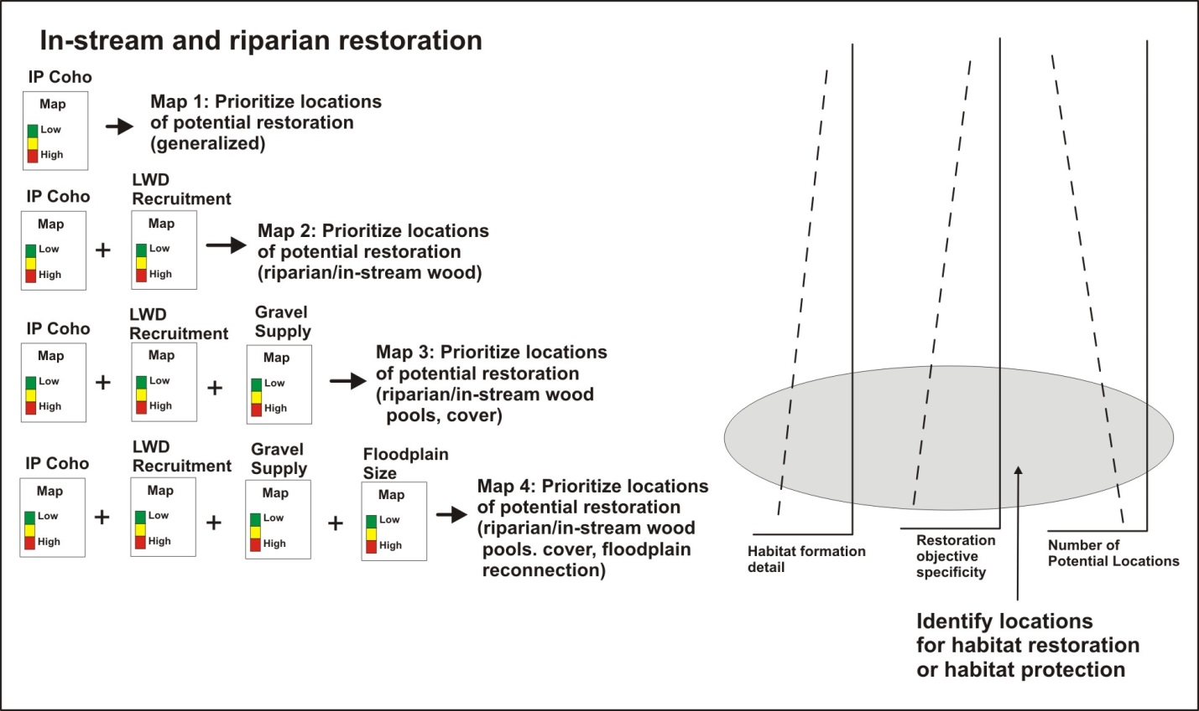

Figure 1. Coho IP modeling can be combined with other stream and watershed attributes to increase information about habitat formation and the specificity of potential restoration projects. The number of potential restoration sites may decrease with increasing number of habitat forming processes.

This tool is in its final stages of development and hence it is not yet part of the publically available NetMap tool kit. However, our team will apply the prototype tool within this project.

(III) Large wood in Oregon Coast Range streams are most effective when they trap gravels thereby creating pools, cover and spawning habitats. However, OCR streams can be naturally low in sediment supply and thus in-stream structures may only capture sand if they are in the wrong locations. NetMap sediment supply and sedimentation tools will be used to map the potential for gravel supply and accumulation. This will require modifying an existing tool to account for particle attrition (as a function of distance from sediment source to sediment sink). See how NetMap’s sediment supply and sedimentation tools were used in the [Mad River TMDL analysis](http://www.epa.gov/region9/water/tmdl/mad/Mad-TMDL-122107-signed.pdf) and in the [Crystal River, Colorado](http://www.netmaptools.org/Pages/NetMap_Crystal.pdf) in support of restoration planning.

What will it tell us? Combining maps of coho IP, with high to low present day wood recruitment, and with maps of predicted gravel supply and accumulation will be used to identify the best areas for riparian enhancement or in-stream placement of structures (Figure 1). These areas may include low gradient channels located immediately downstream of tributary confluences (e.g., certain confluences with high sediment/gravel supply).

(IV) Large floodplains and low terraces that favor development of side channels are a key habitat forming element for coho salmon. NetMap’s floodplain tool will be used to map floodplains and terraces at a range of elevations above the valley floor. NetMap’s floodplain mapping tool was used to develop a [watershed scale restoration](http://www.hydrol-earth-syst-sci.net/15/2995/2011/hess-15-2995-2011.pdf) methodology in Spain. And see how NetMap’s floodplain tool was used in [a watershed analysis in Alberta](http://www.netmaptools.org/Pages/oldman.pdf).

What will it tell us? Combining maps of coho IP, with low to high present day wood recruitment, with predicted gravel supply and accumulation, and with maps of floodplain dimensions will provide a greater degree of specificity in regards to coho habitat forming processes and thus will be used to identify preferential sites for restoration (Figure 1).

Combining coho IP modeling with the three other habitat forming components (others could be included such as thermal loading and beaver habitat but omitted here for simplicity) leads to: i) increasing detail of habitat forming processes, ii) increasing restoration specificity (e.g., wood, gravel, side channels), and iii) decreasing number of potential restoration sites (Figure 1). Overall, the use of the four coho habitat forming components can support identifying, via maps, the preferential locations for either habitat restoration or habitat protection.

**Road related restoration**

Roads, in particular logging roads, can pose a significant threat to coho salmon including creating migration barriers, producing fine sediment in streams, constraining lateral movement of channels, impinging on floodplains and contributing to landslides and debris flows. Mitigating these potential impacts can be part of a watershed restoration strategy.

NetMap contains a suite of road analysis tools and they will be applied in the target watersheds including: stream segment scale road density; cumulative habitat length and quality above all road crossings; road hydo-connectivity (e.g., drainage diversion); road surface erosion and sediment delivery to streams; road stability (landslide and debris flow); and roads in floodplains. The tools will be used in conjunction with coho IP mapping or with the expanded habitat definitions outlined in Figure 1.

What will it tell us? NetMap’s analysis of roads will be used to create a ranking of potential road restoration sites based on: i) calculating cumulative habitat length and quality above road crossings for prioritizing locations for culvert restoration/upgrades, ii) identifying road segments with the greatest potential for fine sediment production and delivery to streams to prioritize maintenance, abandonment, upgrading surfacing, wet weather driving restrictions etc., iii) identifying road segments at greatest risk for triggering landslides and debris flows for upgrading crossings, fill pull back etc., and iv) mapping roads in floodplains and low terraces to identify opportunities for moving road locations. NetMap’s road tools are being used in watershed assessments including for planning restoration in the [Clearwater River, MT](http://www.netmaptools.org/Pages/Clearwater_NetMap_final.pdf) (Collaborative Forest Landscape Restoration Program [CFLRP]), the **Flathead River watershed, MT** (International Memorandum of Understanding between the US and Canada), the [Upper Sacramento River watershed assessment](http://riverexchange.org/Final%20Wshd%20Assess%2019MB.pdf) and in 30 national forests in USFS Regions 6 and 1 (OR, WA, MT, ID).

**Synthesis**: Creating coho habitat indices that account for key habitat forming processes (Figure 1) can be done qualitatively by visually overlaying a series of map products (e.g., Maps 1-4, Figure 1) or it can be done quantitatively, including to ensure consistency and reproducibility across all watersheds. Analysts determine threshold values for the various habitat forming elements (or road related threats); here disciplinary expertise plays a key role. For example, an analyst selects a threshold coho IP value of > 0.7 to identify areas of highest coho habitat potential. To increase the detail of habitat forming processes for restoration planning (e.g., IP + wood; IP + wood + gavel; IP + wood + gravel + floodplains; Figure 1) requires an analyst to select threshold values (or a range of values) for wood recruitment (#pieces/ha or volume/ha, including for particular piece sizes), gravel supply (t/km2/yr) and deposition (sediment supply vs. stream power) and floodplain dimensions (width and length).

To identify preferential locations for habitat restoration and habitat protection, a new NetMap tool will be built that will allow a user (including agencies and watershed councils) to quickly select from a set of habitat forming elements (1–4+, Figure 1) and to select a threshold value for each (< >), a range, or some portion of the cumulative distribution (e.g., top 1%, top 5% etc.) (Figure 2). 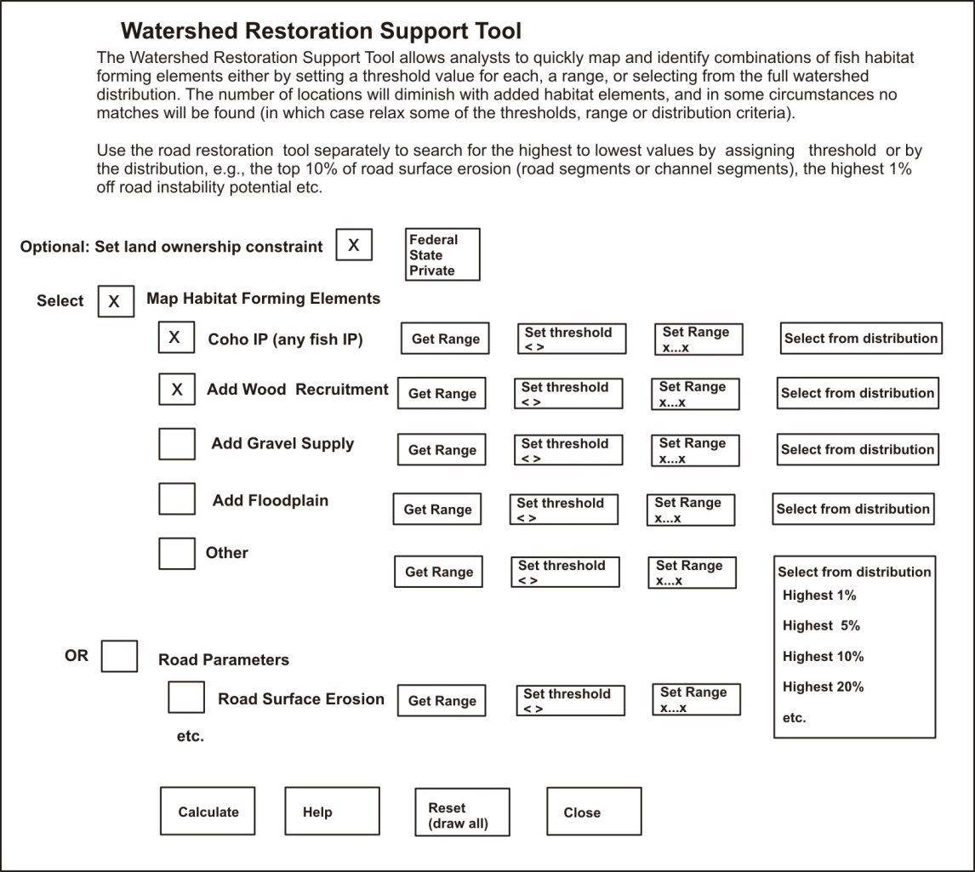

Figure 2. A new Watershed Restoration Support Tool will be built within NetMap. Note the land ownership category (federal, state, private) could be invoked (or not) and hence site selections could be further constrained.

Running this tool will provide a quantitative, consistent and repeatable method within a single watershed or across multiple watersheds (n=21) or target fish populations (n=7) to identify preferential locations for either habitat restoration or habitat protection. Analysts, including within agencies and watershed councils, can combine the qualitative and quantitative approaches, and couple these with field surveys, to develop restoration prioritization and to select project locations.

The analyses outlined above are conducted at the scale of individual channel segments (100 m), individual hillsides (0.1 km2) and road segments (10 m to 1000 m). However, all analyses will be summarized at the scale of HUC 6th level (12 digit) using NetMap tools. For an example, see the **TerrainViewer** and examine patterns of coho IP at the scale of HUC 6th, including for the Oregon Coast Range. Ownership will also be summarized at the HUC 6 scale.

**Question**: What is the degree of resolution and accuracy? Standard NetMap datasets use the 10 m NED DEM, which is adequate for many applications, including the mapping as outlined in Figure 1. However, NetMap can utilize LiDAR and the resultant analyses will be of higher resolution and accuracy. Integrating LiDAR will require rebuilding of the NetMap datasets and this task, at present, can only be done by NetMap programmers. However, we are planning within the next year to provide subscribers of NetMap the capabilities to rebuild NetMap datasets from the ground up in their area of coverage.

If LiDAR is available, we highly recommend creating new NetMap datasets (this may require merging LiDAR with 10 m DEMs).

**Question**: Can finer scale habitat survey data be added to the NetMap system? Yes.

**Question**: What form would you suggest the output be handed off to the various agencies and watershed councils? The analyses will cover either 21 individual watershed or 7 individual fish populations (watersheds). Thus, the analysis output should be standardized across all of them. We recommend a standardized report structure describing the goals, science background, habitat forming elements (Figure 1), methods, result formats (Maps 1-4, Figure 1), interpretation, limitations and a practitioner’s field guide to model output including field validation, updating predictions, and creating priority lists etc.

Therefore, the report structure and most text would be standardized across all watersheds; the actual map products would be unique to each watershed. As part of the project, TerrainWorks staff would create the initial map products, including the use of professional judgment on setting pertinent habitat element thresholds and ranges (e.g., Figure 2).

Question: Would TerrainWork’s staff provide an analysis protocol including for interpreting results? Yes, see above.

**The online tool option**

NetMap tools operate within ArcMap software and hence model outputs are in the form of GIS shapefiles. GIS can become a bottleneck to the transfer of information since it requires expensive ArcMap software and the expertise to run it. One alternative to increase dissemination and use of information from NetMap analyses is to provide the watershed data within an online mapping interface, including the ‘Watershed Restoration Support Tool’ (Figure 2). TerrainWorks, in collaboration with **Mazama Science**, has been building non-ArcGIS online tool capabilities in NetMap. For examples, see the **TerrainViewer** and **FireView**.

**Question**: NetMap licenses? If TerrainWorks conducts the project across the entire project area as outlined above for a cost of $115K (see below), NetMap tool and data licenses will be provided to all participating agencies and watershed councils. The tools do not expire but continued access to tool updates, new tools, and support will require the optional annual licenses following the first year.

**Cost options:**

**Option A:** TerrainWorks completes the project as outlined above (Parts A and B) for the entire project area, including building the new Restoration Planning Tool (Figure 2). This includes creating new NetMap datasets using all available LiDAR in the Oregon Coast Range that may require validation of stream layers by local agencies and watershed councils. It also includes NetMap subscriptions for all participating agencies and watershed councils): $115K

**Option B:** Option A + non ArcGIS the online tool: $130K

**Option C:** Demonstration analysis ($15K) only: Conduct Part A in the target watersheds identified by NOAA and develop a short report that outlines how NetMap tools can be used to conduct analyses as outlined in Part B.

**Option D:** Only obtain NetMap subscriptions (using 10m NetMap datasets). Cost approximately $4K per agency and $2,500 per watershed council. Not included: LiDAR datasets, Restoration Support Tool (Figure 2), standardized reporting format and the online tool option.